Introduction/ Issue:
If a switch will go down users unable to connect the internet not able to work any application and not able to access internet.
How can troubleshooting for a Network switch down?
- We need to trace out the switch IP For down switch.
- We will try to ping the switch ip from Command prompt and see the out put about the loss, I share demo ping snap.
- We will see the switch status in the Monitoring tool in SolarWinds.
- We will try to do SSH , But not able to do remote session out.
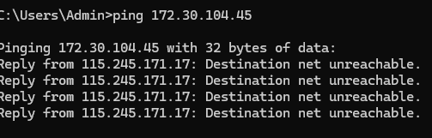
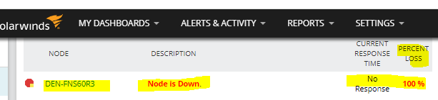

Why we need to do / Cause of the issue:
How does issue occur?
The switch will down for various reason, I will update couple of cause on below.
- Site power outage no power in the switch, its cause the switch goes down.
- Bad ups, Is switch connected UPS Is dead and not working,
- Power cable or power port damage.
- Uplink cable removed of damage.

How do we solve:
- We will do switch IP ping, trace, and we will try to login but no luck.
- We will connect with Local contact to check power status of device and power outage status of site.
- If power is available, we will go to check UPS bad or functioning properly or not.
- If all troubleshoot complete, we will check switch having power but not coming online,
- Next step we will reboot the switch for 30 seconds, then it will back restore.

Conclusion:
- We will do all the L1 Level the troubleshoot, like ping test , ssh, look the alerts status of SolarWinds.
- Then we will contact to LCON , Will check power status of site and switch power status.
- Then will Check Ups Status and uplink cable etc.
- If all ok and switch having power light all light, but not coming up .
- We will go final step to reboot the switch , once Switch reboot and restored , Switch will get to back online
- If all thing did but no luck, We will connect the console on switch help of the LCON AND We will try to take console and update if any configuration Mismatch.

Note: Post the blog in SharePoint. After your manager’s review, you can post it in our website.

