ORACLE CLOUD INTERGRATION:
Steps To Set Up Visual Builder On Oracle Cloud
1) Register & Log in to the Oracle Cloud account, cloud.oracle.com.
2) Click on the hamburger menu, Under More Oracle Cloud Services, expand Platform Services and click on Visual Builder as shown below:
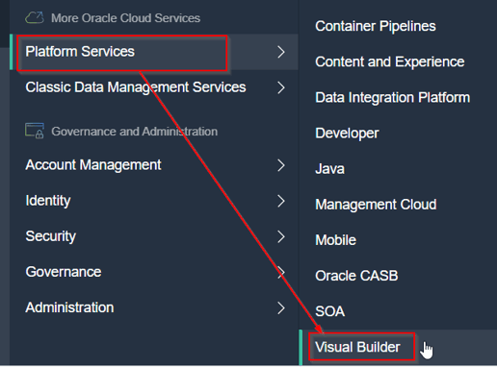

3) You will be redirected to a Welcome page when you click Visual Builder. Just click on Instances.
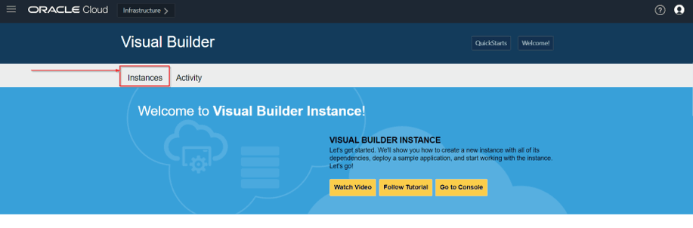

4) On the Visual Builder page, you can create an instance in two ways:
- Create QuickStart Instance
- Create a custom Instance

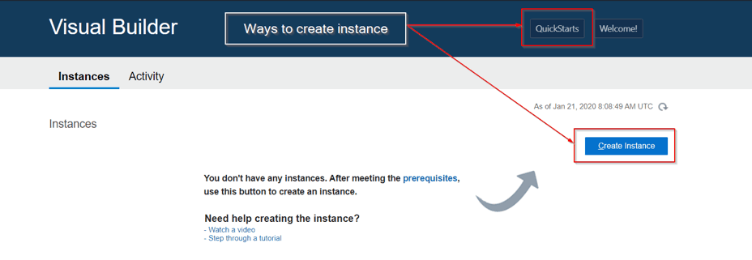

5) You will see a create instance page where you can name the new instance and can see a description of the features of the QuickStart instance. Type the instance name in the Instance Name field and click on create.
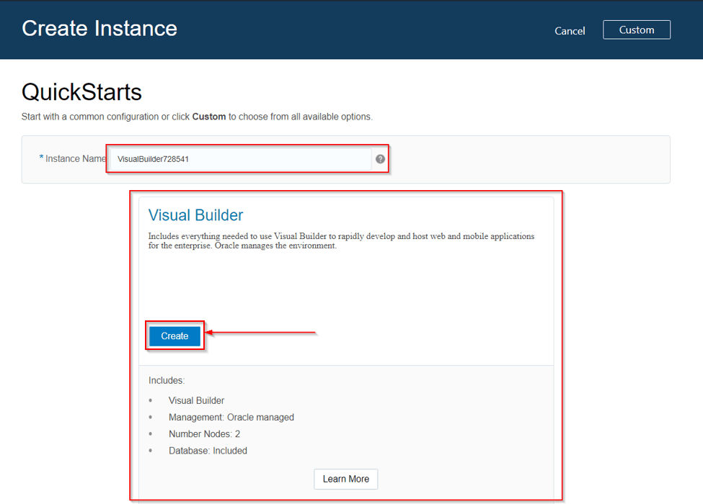

4) Once the services are created, an instance will be available on the Visual Builder console.
