**Delete Button Does Not Appears On Transaction Page And Not Able To Delete An Invoice In Receivables**

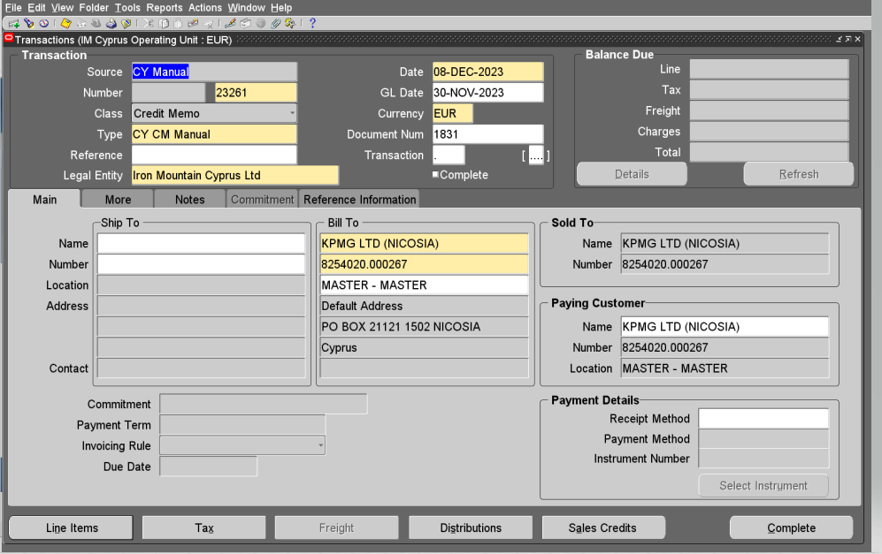

**Delete Button Does Not Appears On Transaction Page And Not Able To Delete An Invoice In Receivables**

STEPS  
-----------------------  
The issue can be reproduced at will with the following steps:  
1. Go to Navigator > Receivables > Billing  
2. Go to Transactions > Manage Transactions  
3. Query the transaction  
4. Review the transaction and the "Delete" button does not appear

Solution

To implement the solution, please execute the following steps:  
  
  
1. Go to Navigator > Setup and maintenance  
  
2. Go to task Tab  
  
3. Query for Manage Receivables System Options  
  
4. On Manage Receivables System Options, review the options:  
  
- Allow change to printed transactions  
- Allow transaction deletion  
  
5. Check those two options  
  
6. Save  
  
7. Retest the issue.  
  
8. Migrate the solution as appropriate to other environments.

