Min Max Planning by Requisition in Oracle Fusion Procurement SCM

Table of Contents
Contents
1. Overview 3
2. Technologies and Tools Used 3
3. Use Case 4
4. Architecture 5

Overview

Overview of Min Max Planning
Item can be replenished through Min Max Planning at
- Inventory Organization Level
- Sub-Inventory Level
Inventory Organization Level

Min-Max planning replenishes a particular item in an inventory organization. When you use inventory organization-level min-max planning, inventory balances, purchase requisitions, inbound transfer orders, and work orders are treated as supply, whereas sales orders, outbound transfer orders, and account issue movement requests are treated as demand

Sub-Inventory Level
Min-Max planning replenishes items in a subinventory using the minimum and maximum inventory levels and fixed lot multiple values that you specify for a particular item subinventory. When you use subinventory-level min-max planning, inventory balances, inbound transfer orders, purchase requisitions, and movement requests are treated as supply.

Technologies and Tools Used
The following technology has been used to achieve the same.
- Oracle Application Development Framework - JDEVADF_12.2.1.6.0ADF-REL132304-PROD-BP_GENERIC_230524.1521.S
- Oracle Middleware Extensions for Applications -ATGPF_PT.12C.2304_GENERIC_230525.1402.REL13BP68.6

Use Case

Min Max Planning replenishment by Requsition
To replenish Item automatically by Requisition through Min Max Planning, complete the following configurations.
1. Create an item with the following prerequisite setups:
- The item has a default buyer.
- On the Planning specifications tab of the Create Item page in Oracle Fusion Product Information Management (Item > Specifications > Planning), set these parameters for the item:
- Set the Replenishment Source Type to Supplier
- Set the Inventory Planning Method to Min-Max Planning
- The item should have a list price under the organization for which you're trying to replenish.
2. On the Manage Inventory Organization Parameters page, set the item source details type to Supplier.
- From the Setup and Maintenance work area, go to the Manage Inventory
- Organizations task.
- On the Manage Inventory Organization page, search for your organization.
- Click the Manage Organization Parameters button.
- Select the Item Source Details tab.
- Select Supplier in the Type field.
3. Check that the implementation status for Manufacturing and Supply Chain Management is set to Implemented.
4. Use the Manage Supply Request Exceptions page in Oracle Fusion Supply Chain Orchestration to check for an exception message. If there is an exception for the batch, it's listed in the search results.
5. Ensure that the INV_MINMAX_REORDER_APPROVED profile option is set to Preapproved at the site level.
6. You should order only when the available quantity is less than the minimum quantity. If the available quantity is greater than the minimum quantity, no replenishment order (purchase requisition) is created.
7. If you receive any import errors, search the POR_REQ_IMPORT_ERRORS table and verify the error details.

Architecture

Create Purchase Requisition using Min-Max Planning
Steps:
- Navigation → Product Management →Product Information Management
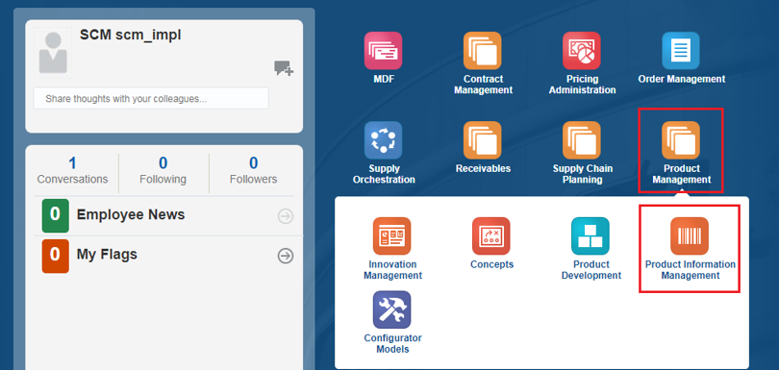
Click on Task Icon → Manage Items
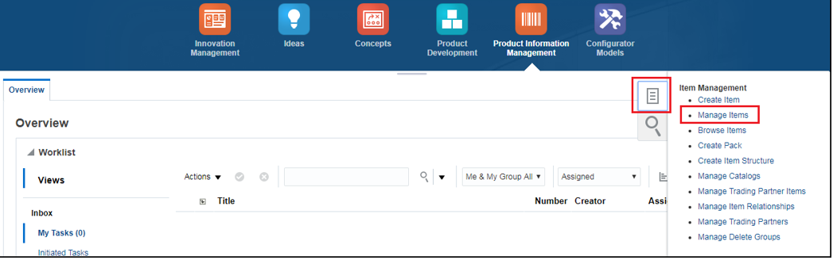
Query the Item and modify the Attributes → Enter the Item and click on search

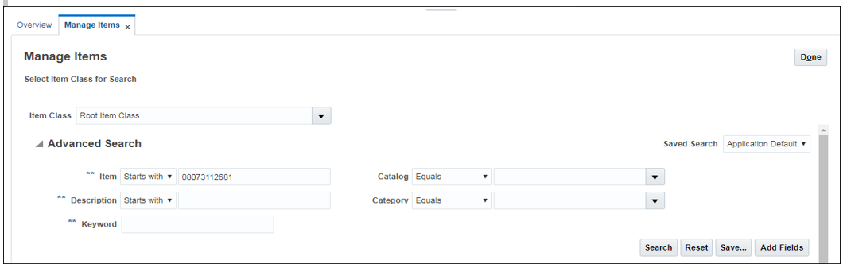
Click on the Item with respect to the Warehouse you want to enable the Min-Max Planning for the item.
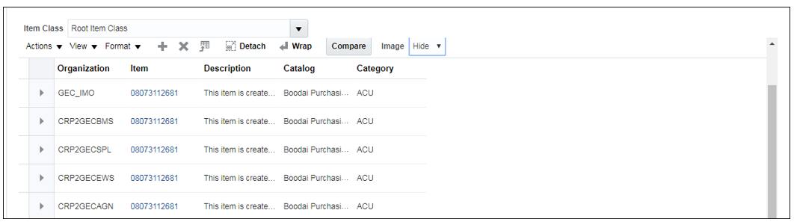
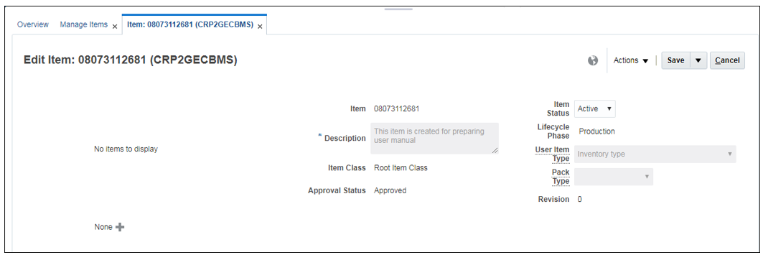
Modify the Attribute under Specification → Planning tab
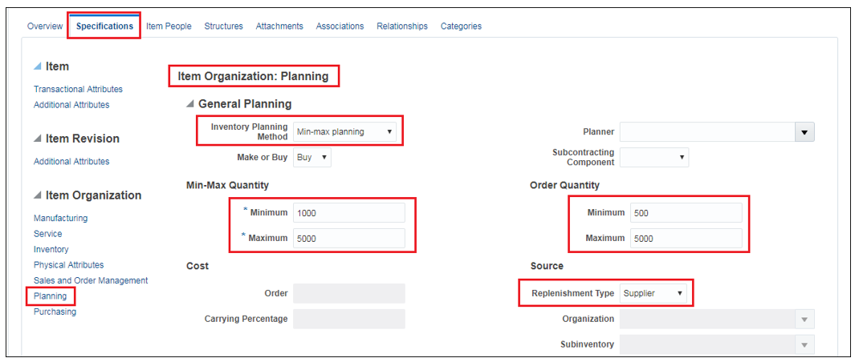

Under Planning Tab, Enable the below Attributes
- Inventory Planning Method → Min-Max Planning
- Source → Replenishment Type → Supplier
- Min-Max Quantity → Minimum → Minimum Quantity for the Item
- Min-Max Quantity → Maximum → Maximum Quantity for the Item
- Order Quantity → Minimum → Minimum Order Quantity to the Supplier
- Order Quantity → Maximum → Maximum Order Quantity to the Supplier

Please note that when Min-Max Planning is enabled, the Min-Max Quantity and the Source are Mandatory whereas the Order Quantity is optional.
Click on Save and Close.
Now, Run the Min-Max Planning Report under Scheduled Processes
[N] Navigator → Tools → Scheduled Processes
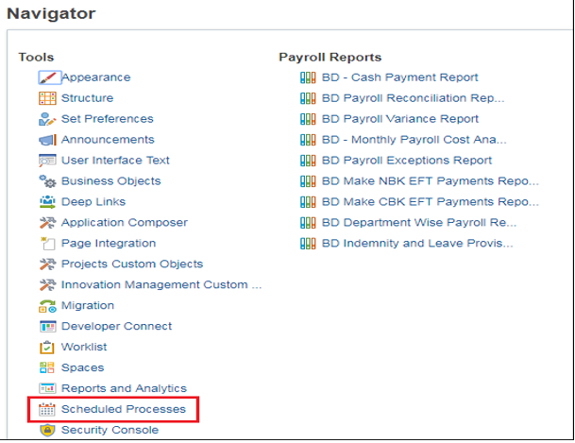

Click Schedule New Process
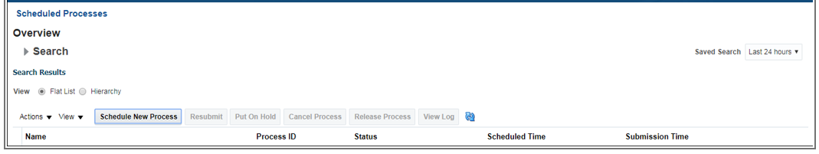
Report Name - Print Min-Max Planning Report
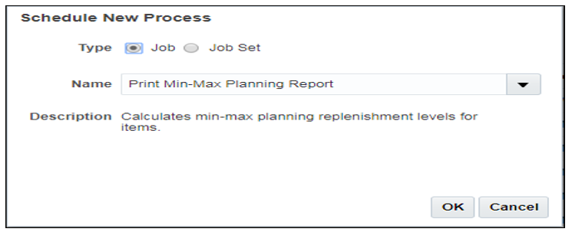
Click OK
Enter the Parameter as per the below screenshot
- Organization
- Sort By
- From Item
- To Item
- Planning Level
- Item Selection
- Demand Cutoff Date
- Demand Cutoff Date Offset
- Supply Cutoff Date
- Supply Cutoff Date Offset
- Restock – (YES) – This Attribute determines whether the Purchase Requisition has to be created or not.

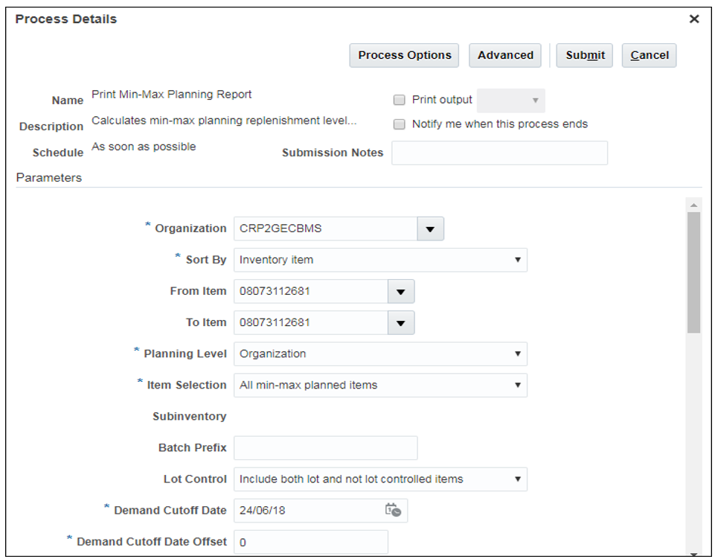
Click on Submit.
Select the Report, scroll down and Click on Republish
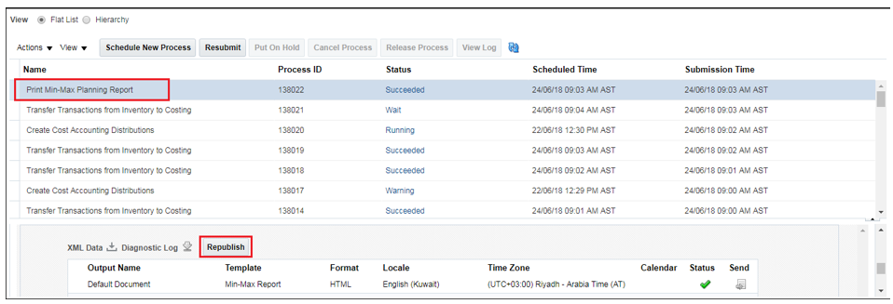
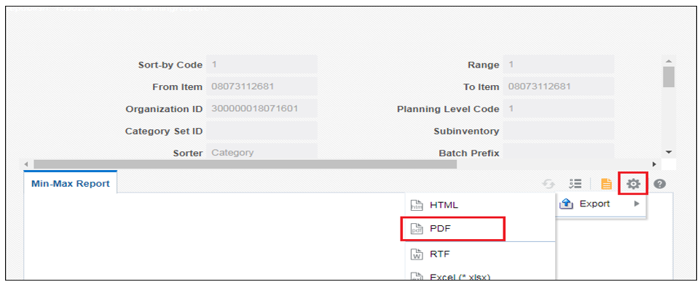
The Report output shows the Reorder Quantity as 4910 since we already have 90 On-hand quantities.
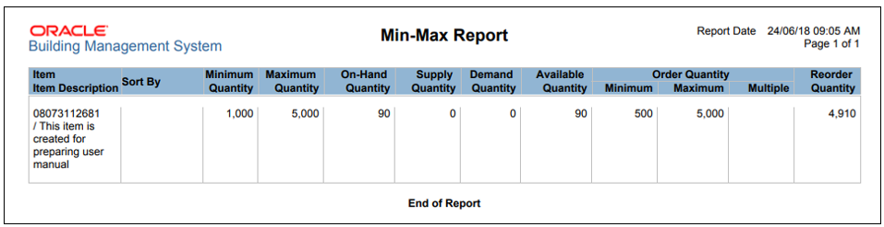
Then another scheduled job called “Process Supply Chain Orchestration Interface” is scheduled to run every day, this program will pick up the records and will push to Requisition Interface.
[N] Procurement → Purchasing
Click on Task Icon → Process Requisitions
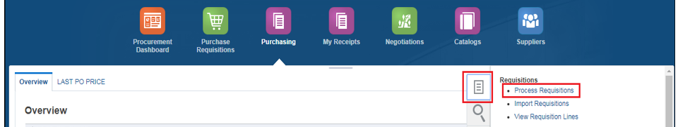

Select the Requisitioning BU, Remove the Buyer Name (leave it as Blank) and Click Search
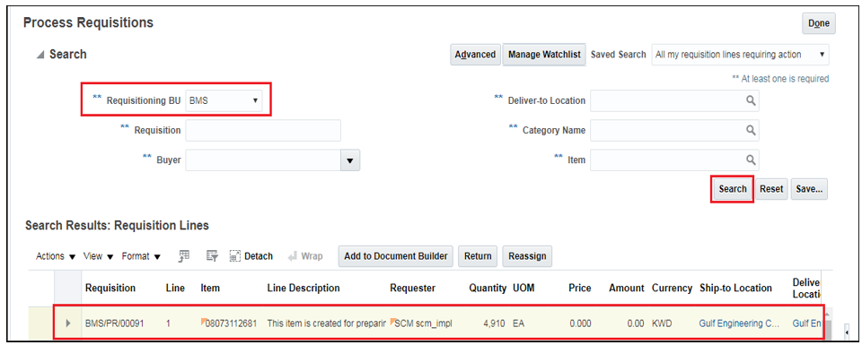
You can see the Requisition is created for 4910 Quantities

