Value sets used for Shipping Goods in Oracle Fusion Procurement SCM

Table of Contents
Contents
1. Overview 3
2. Technologies and Tools Used 3
3. Use Case 4
4. Architecture 5

Overview

Receive Items into Inventory
Overview of Tasks from the Inventory Management Work Area Use the task panel on the Inventory Management work area to access your inventory, shipping, and receiving tasks. Click Show Tasks in the task pane to toggle between these main categories:
• Inventory
• Counts
• Shipments
• Picks
• Receipts
Once you select a main category, you can view all the tasks in that category. Click a task link to open the User Interface
Note. The list of tasks you can view and access depends on the products your enterprise has licensed and configured and the security privileges and roles assigned to your user account.
Task | Description
Receive Expected Shipments | Search, review, and select shipment lines to receive.
Manage Inbound Shipments | Search, review, and select inbound shipments to modify.
Create ASN | Maintain and communicate the advanced shipment notice
Create ASBN | Maintain and communicate the advanced shipment notice and billing notice
Upload ASN or ASBN | Upload advanced shipment notices and advanced shipment and billing notices

Technologies and Tools Used
The following technology has been used to achieve the same.
- Oracle Application Development Framework - JDEVADF_12.2.1.6.0ADF-REL132304-PROD-BP_GENERIC_230524.1521.S
- Oracle Middleware Extensions for Applications -ATGPF_PT.12C.2304_GENERIC_230525.1402.REL13BP68.6

Use Case
NA

Architecture

Receive Item against Purchase Order into Inventory
Steps:
[N] Warehouse Operations → Receipts
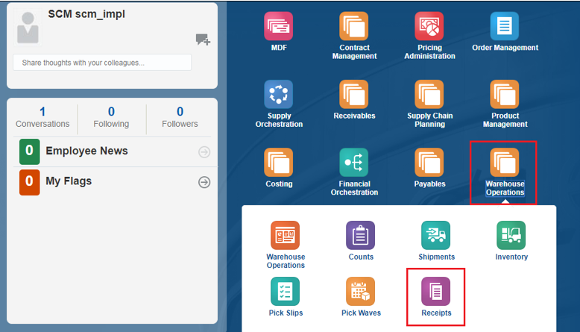
Select the Organization from the List of Values
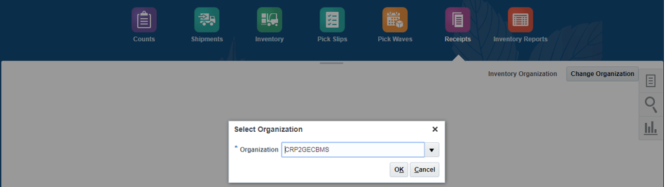
Click OK

Click the Task Icon → Receive Expected Shipments
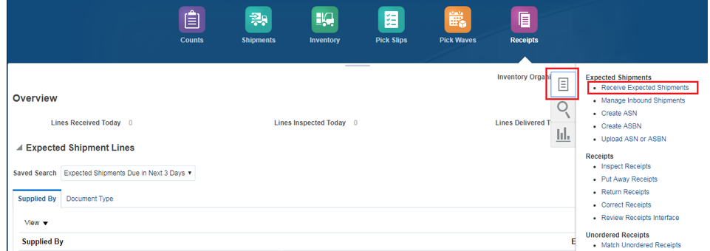
You can enter any of the Below Information to Receive the Material (Any one is Mandatory).
- Purchase Order Number
- Supplier
- Item
Due Date → Leave it as Blank
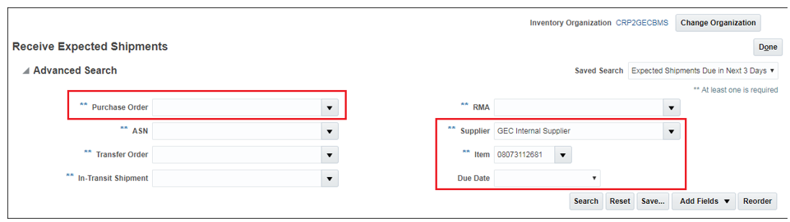
Click on Search
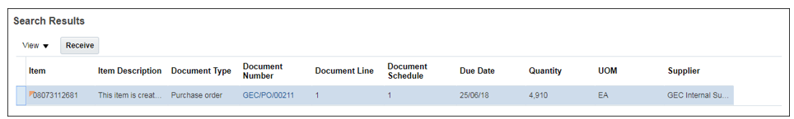
Select the Line and click on ‘Receive’ button

Enter the Quantity, UOM, Sub inventory and Locator
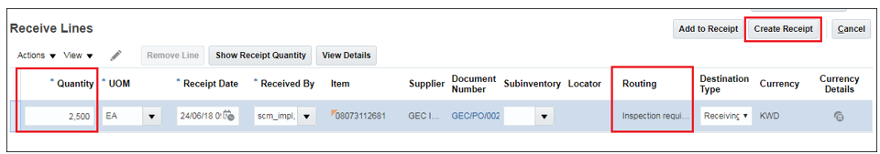
If the Purchase Order is created in a different currency (USD), then click on the Currency Details and enter the Exchange Rate (Date) when you are receiving the Material.
Please note that the Exchange Rates (Dates) are maintained in the system by Finance department.
You can also receive the Material in different UOMs, the conversion will be done by the system automatically.
Example: - 1 BX contains 25 each
Then, you can enter the quantity as 2 and receive the Material in BX UOM.
This means we are receiving 50 (EA) quantities in the system.
Click on Create Receipt
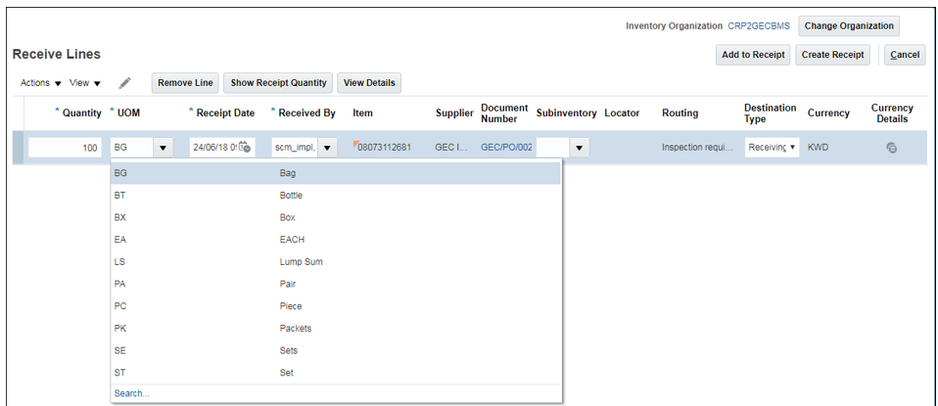

Once you click the Create Receipt button, the below page appears where you can enter the details like
- Delivery Note
- Invoice Number
- Packing Slip
- Notes, etc.
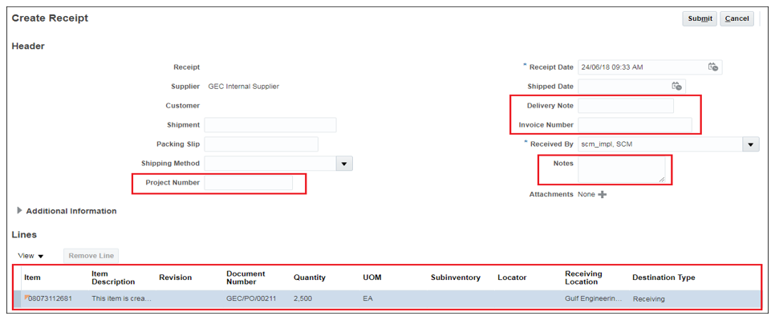

Click on Submit.
Click the Task Icon → Inspect Receipts
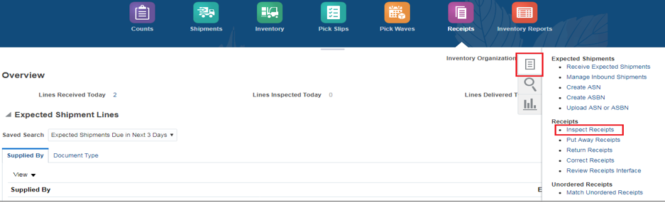
Enter the item in the search criteria and click search
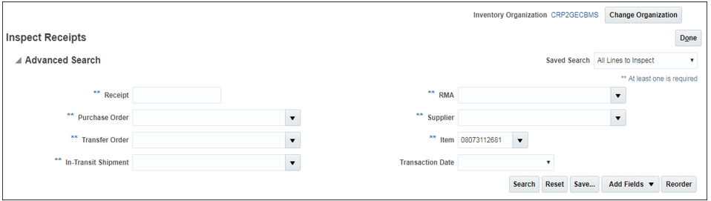
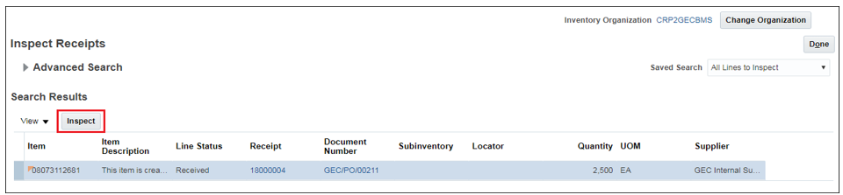

From 2500 quantities, you can split the line and inspect the material.
Example: - Out of 2500, 2000 quantities are Average and 500 is below Average
Click on Action → Split Line
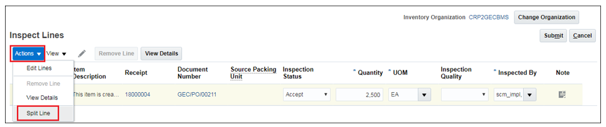
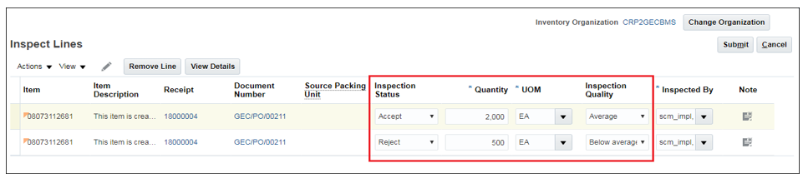
Click on Submit
Now, Click the Task Icon → Put Away Receipts
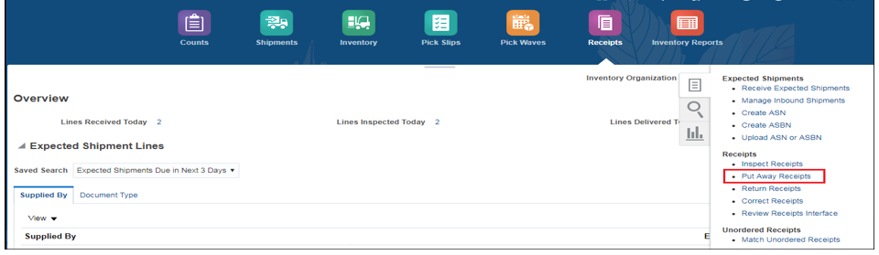

Enter the Item in the search criteria and click on Search
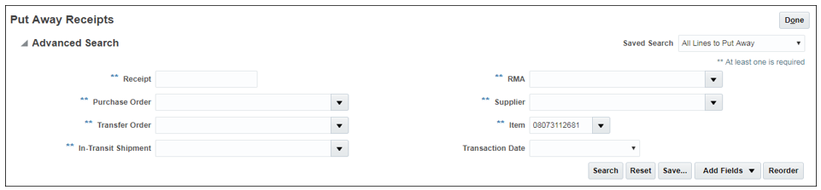
The system will allow you to receive both 2000 as well as 500 quantities
Select the line and click on Put Away
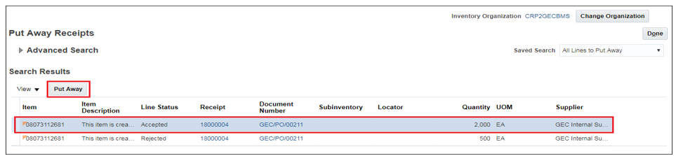
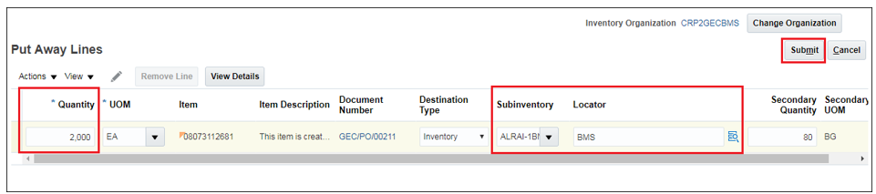
Click on “Submit”
In the same way, receive the remaining 500 quantity as well into the inventory.

