How to Configure Invoice Approval Rules for Different Purchase Order PO Matched Scenarios

Scenarios

The requirement is as follows:   
1. If a Invoice has a PO is matched at header level, it should be auto approved.  
2. If a Invoice has all lines which are PO matched, it should be auto approved.  
3. If a Invoice has PO matched lines as well as unmatched lines, it needs to be sent for approval.

**Rules Configuration:**

Two achieve the above requirement, we need to configure two approval rules one is for all invoice lines matched to PO and another rule is for partial invoice lines matched to PO.

1. Rule1: To achieve the requirement 1 & 2, We need to configure one rule with advanced options as follows:

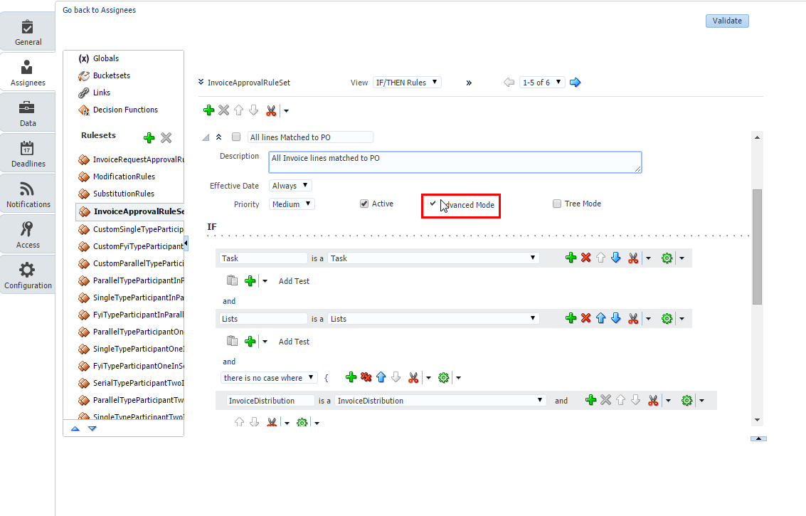

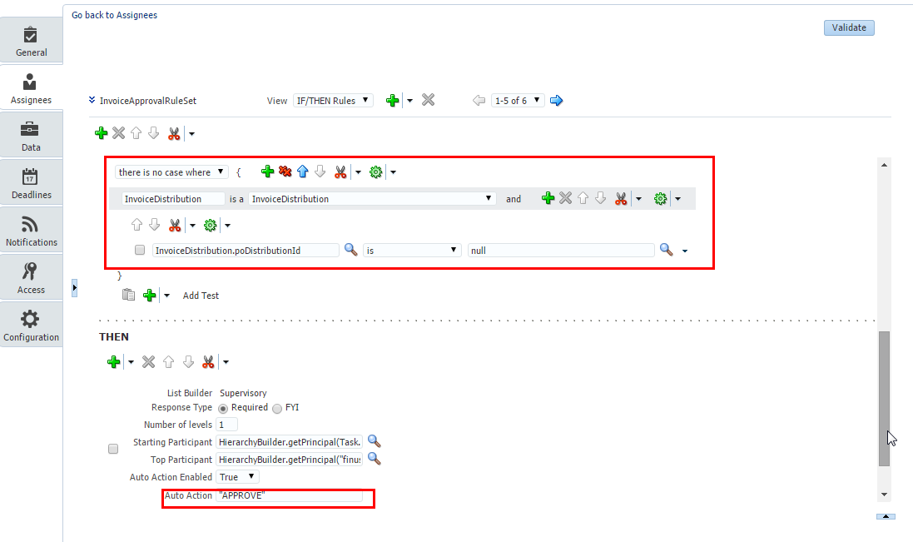

1. Rule2: Configure another approval rule with advanced options as follows to meet the requirement3:

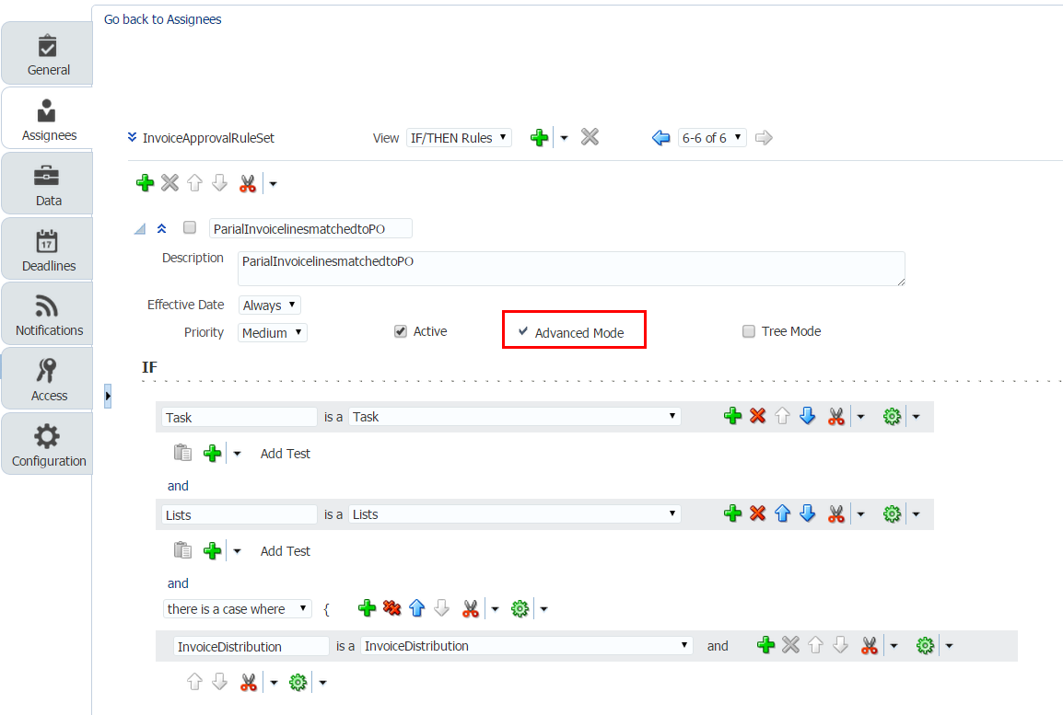

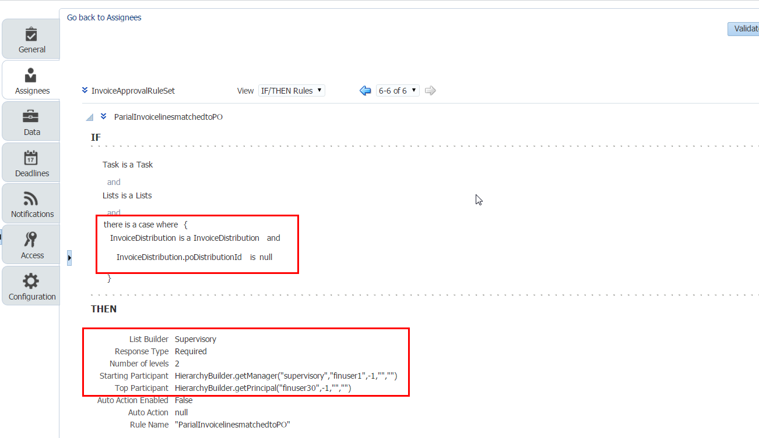

**Note: Approval rules configured based on PO distribution ID availability on invoice distributions.**

**To work these rules, Invoice needs to be validated first or invoice distributions need to be generated explicitly by opening invoice distributions UI and click on save and close which will generate the distributions for invoice.**