Step1: Navigate to Set Up And Maintenance 🡪 Search Task 🡪 Manage Administrator Profile Values.

Step 2: Search with Profile Option Cod as FND_LANGUAGE

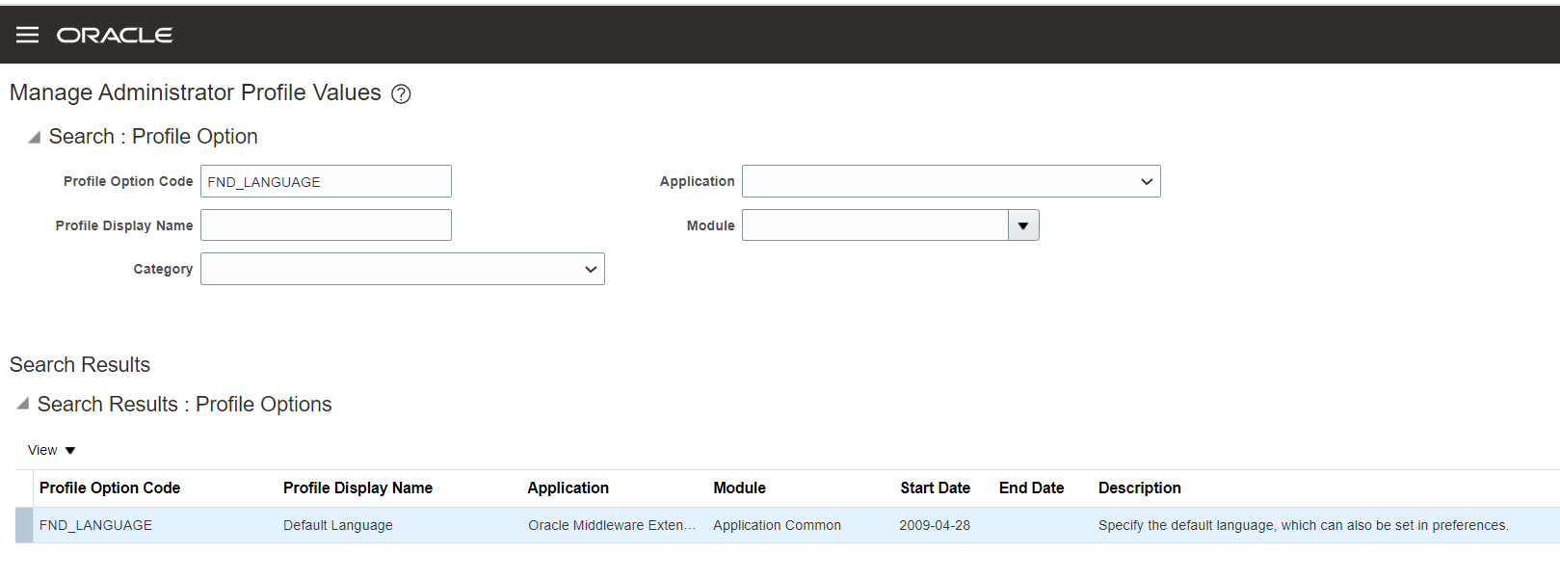

Step 3: Search for User Name FUSION_APPS_HCM_ESS_LOADER_APPID and select the required Language for Profile Value.

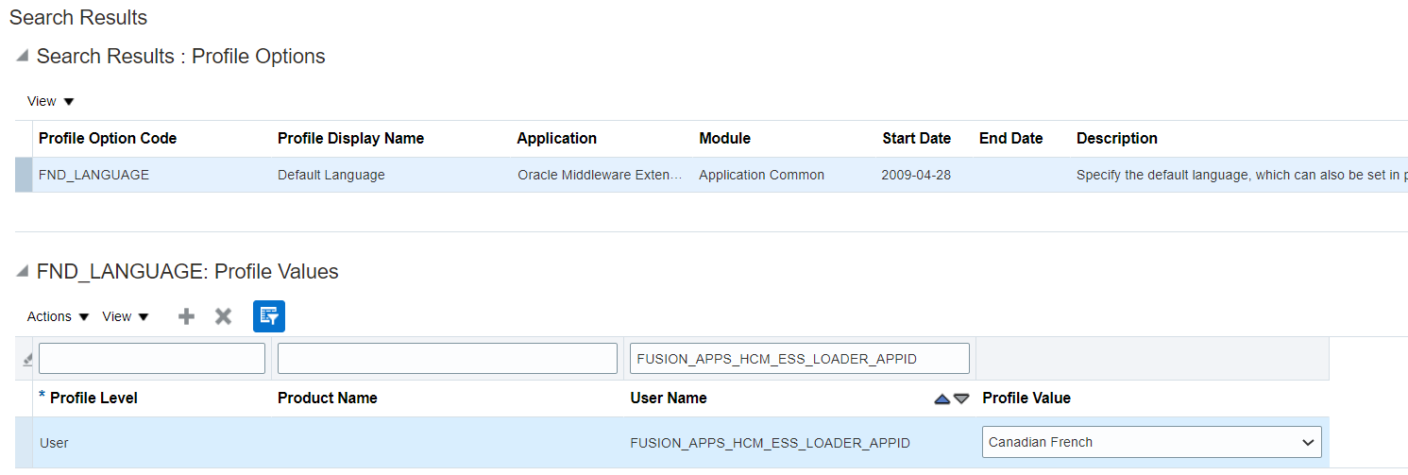

Step 4: Save and Close the Work.