**Create Oracle BI Publisher Report**

Log into Oracle BI Publisher

Click Create a new report

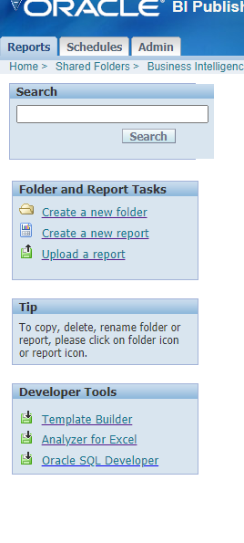

Enter report name and click create

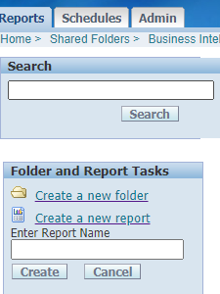

Click on new to create data model

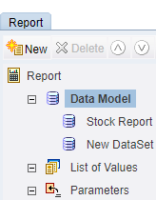

Give data set name select type as SQL and select DB source

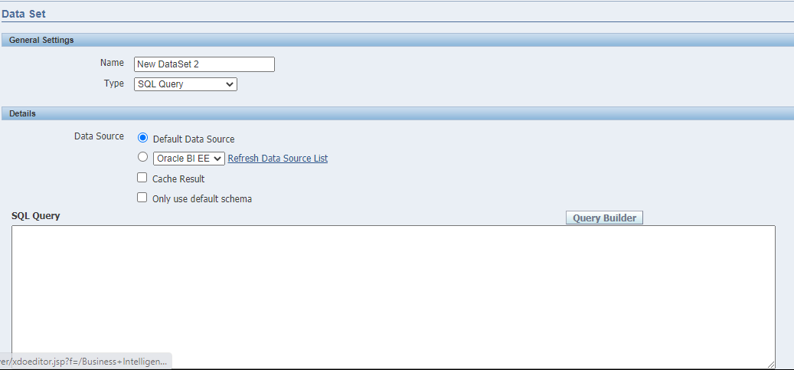

Click on save button once you have done with data set

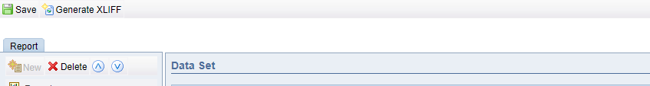

Click view for viewing data as per SQL done with data set

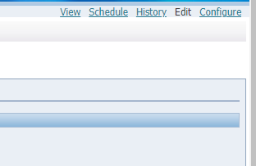

Click on export to export data into XML format



Load sample XML exported into BI publisher menu

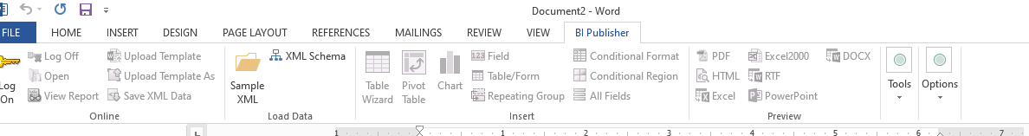

Create Layout as per requirements.

Upload template under manage template files

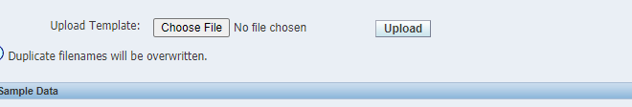

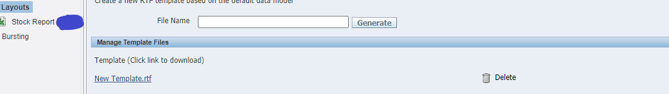

Select template type

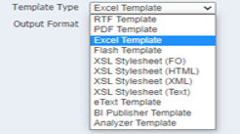

Click on save after attaching template



Add parameters LOV if needed



Click on view to view output

