**To find the Error In Apex,What's going in APEX? The easiest way to Debug and Trace an Oracle APEX session.**

* **This is one of the very important as a developer prospective, Like which Page ,Application, containing error, slowness and Performance issue.**
* **So many scenario we see the slowness of Page complained by User. But we can check step by step here. Also only creating index not at all solution for every scenario.**
* **In Oracle APEX 5.1, 18.1….., here's how you start to see..**

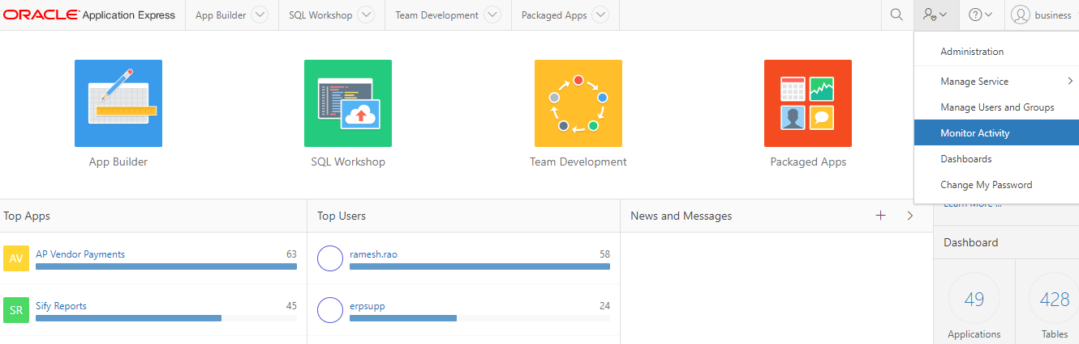

Here Click on Active Session, You can see the details of user’s , ip and other details .

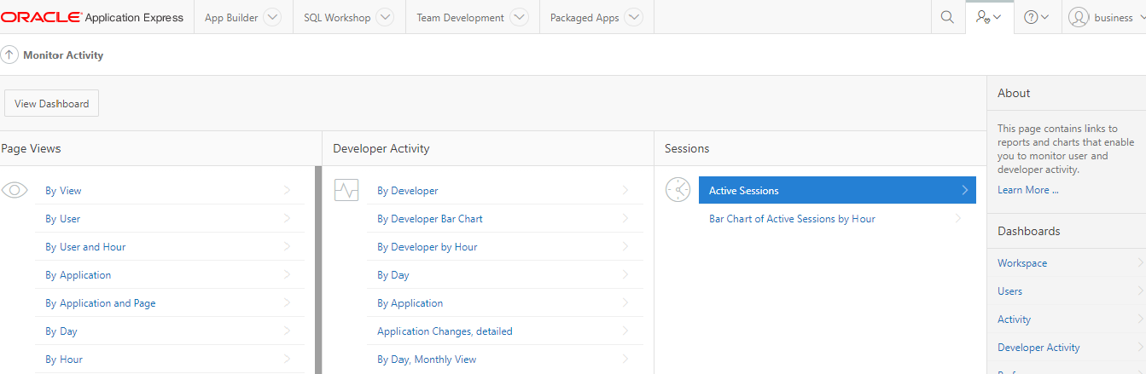

You can see the active session, Owner, Ip , Timing and other’s deails.

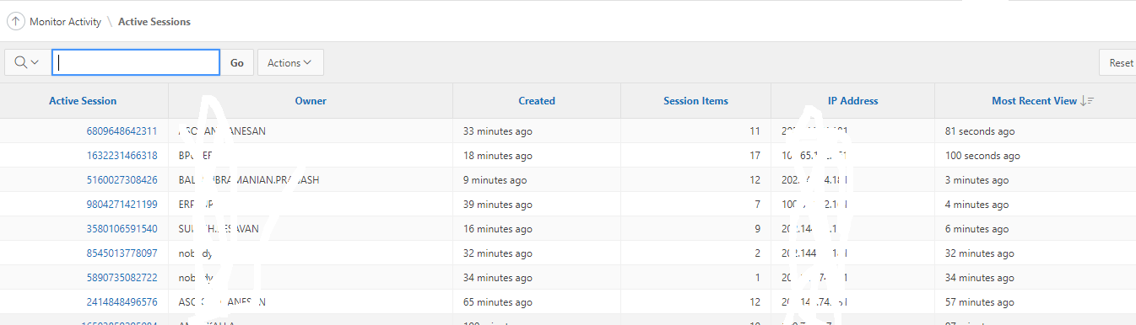

After that You can check and select any active session, which you want to trace.

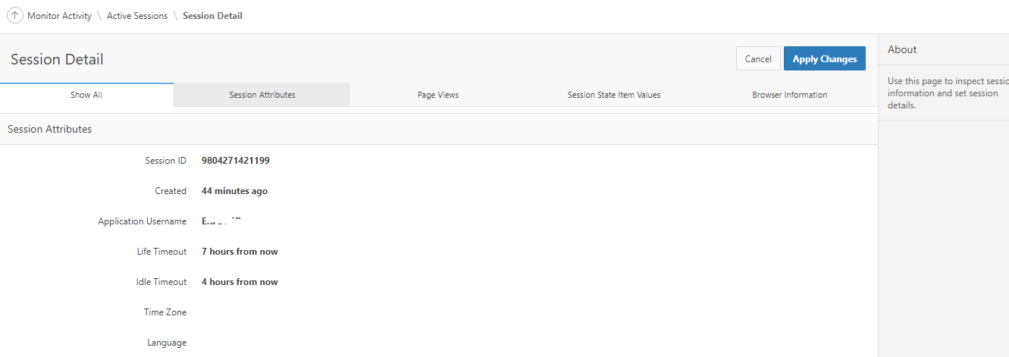

You can see the all details in below Reports like which Application no , debug id , page ,error message and other details here

Click here any debug and or session id- then you can see the below option, trace and Apply.

So easily monitor the application slowness issues.

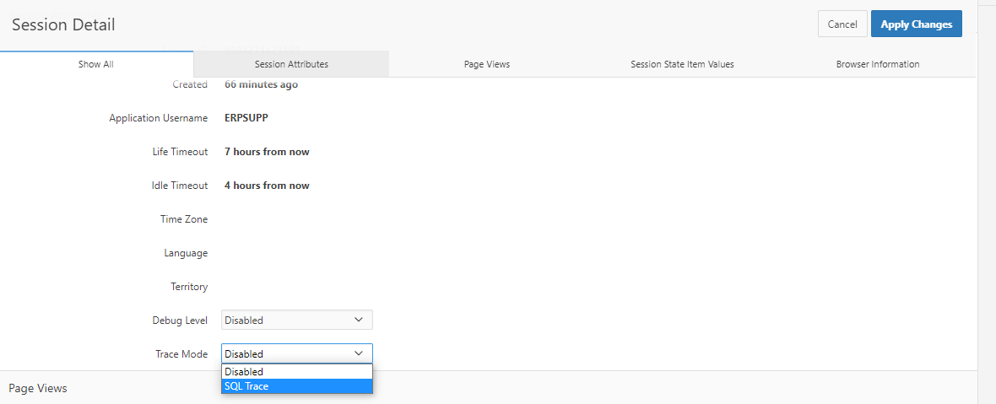

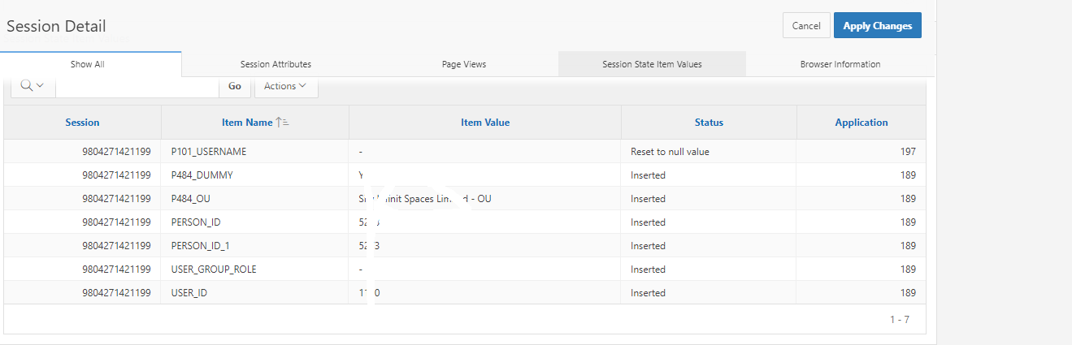

Thanks