**[Creating Customer in Oracle Fusion](https://rpforacle.blogspot.com/2018/02/creating-customer-in-oracle-fusion.html)**

**Creating Customers in Oracle Fusion**

Creating Customers in Oracle Fusion

To create a customer, you must specify at least a customer name, Account Address Set, account site address and business purpose.

Step1:-

Log in Billing responsibility.  Navigate to the Create Customer window.

Navigator >  Receivables > Billing

[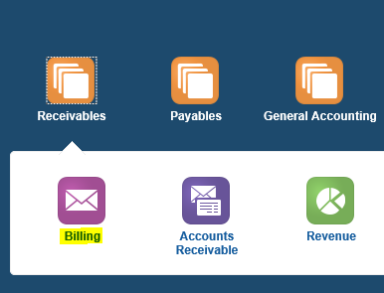](https://3.bp.blogspot.com/-aayG_kZsw9g/WpY5fUms8fI/AAAAAAAABss/PCOdWLknKc4WzrE9aL9GrSOANjwFDmJogCLcBGAs/s1600/fd96.PNG)

[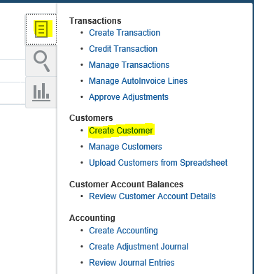](https://1.bp.blogspot.com/-kxyMeVu9caU/WpY5tRjJdYI/AAAAAAAABsw/VQYOaE0QXVIZa066OxdebFWIvUbYwzkGQCLcBGAs/s1600/fd94.PNG)

Step2:- Enter Customer Name in the Organization Name field  
The default Customer Type will be Organization. You can also change to Person.  
  
In the Account Information section of the window, optionally enter and account description, account type and customer class.

[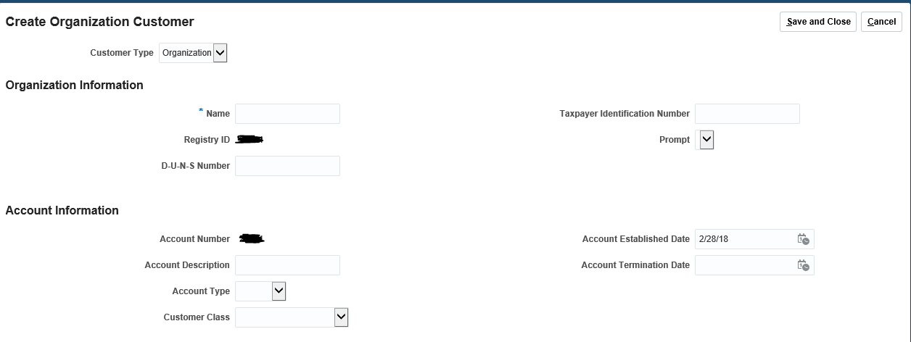](https://3.bp.blogspot.com/-ZlsPCo44lKI/WpY6UnG205I/AAAAAAAABtA/AuuffSsvHVoNbXqfEmtwl1XmVag5suAdwCLcBGAs/s1600/fd97.PNG)

Step3:-  
Navigate to the Account Address area.  Select the  Account Address Set from the drop down list  
Enter the site address information including Country, Address Line 1 – 3, City, State.  
  
  
[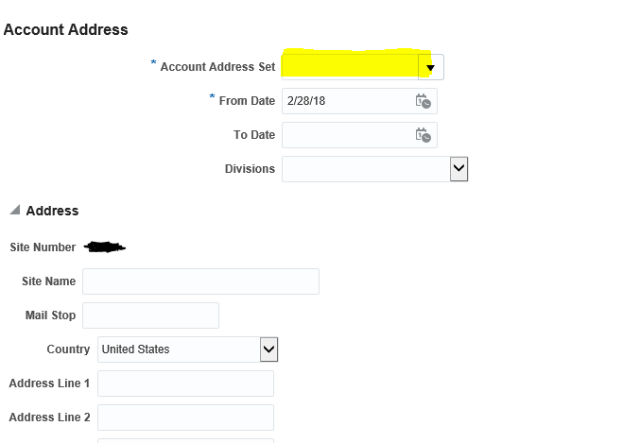](https://1.bp.blogspot.com/-xtGTk8vm24w/WpY6NvSS9wI/AAAAAAAABs8/2GVu3NJWcecopgwBSc_oQesRexvyv2N6QCLcBGAs/s1600/fd98.PNG)

**Step4:- Creating Bill to Ship To Sites**

Scroll down to the Address Purposes section of the window.  Click the plus + sign to add address purpose 'Bill To' or 'Ship To'  
  
  
Step5:-Click the plus + sign again to add a second address purpose 'Ship To' purpose and select the Bill To Site Address you just created.

[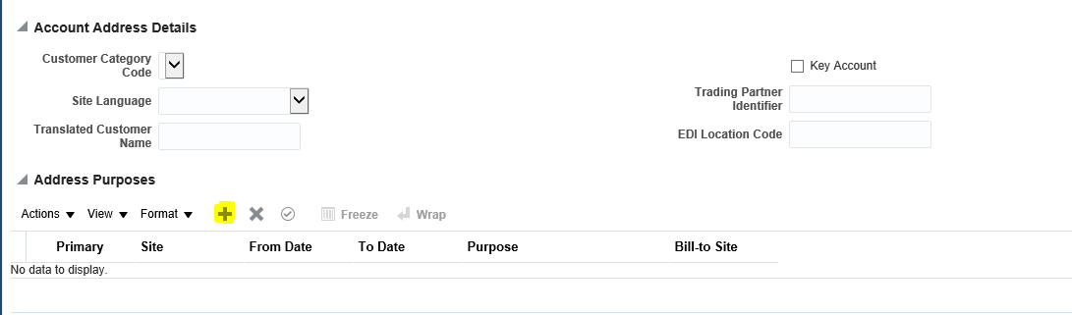](https://1.bp.blogspot.com/-uKNgLKwoKoQ/WpY6dfuCUqI/AAAAAAAABtE/NfFSK1W_tI8IwvmQW-UN9HrI5JdugA_kwCLcBGAs/s1600/fd99.PNG)

Step6:- Now Save and Close your Details.  
  
  
Step7:- Now next step is to Add or Assign customer Sites to Business Unit. For this you need to go back to the Task list again and select Manage Customers.  
Enter customer name in the Organization Name filed click on search

[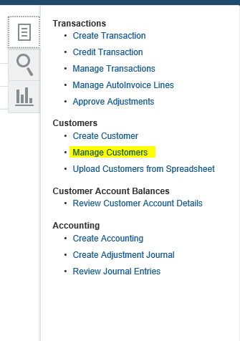](https://2.bp.blogspot.com/-yJX7E0r4AkQ/WpY6nlgg5CI/AAAAAAAABtI/gwxcRRFZvy4Fj5n2MEtCuiP50dfgX3YpgCLcBGAs/s1600/fd100.PNG)

**Step8:- Assign Customer Site to a Business Unit**

Click on the Site Number at the end of the search result page         
  
Under Reference Accounts click on Create icon to add Business Unit to Customer Site.  
 Enter the GL Accounts  
(B) Save at the top of the page

[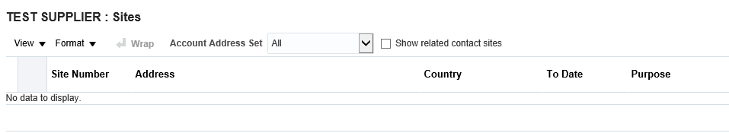](https://4.bp.blogspot.com/-j_MP2gQ6Hl4/WpY65tXC6eI/AAAAAAAABtQ/NLXfalkbC-gaMY51QF67q4SZ6pk9zEPUgCLcBGAs/s1600/fd101.PNG)

**Step9:- Defining Customer Banking Details**

Click on payment details tab  
Under Payment Instruments click on Bank Accounts tab.  
You can either create a new one or use an Existing Bank Accounts.