**[AR Period Close Process and Open Close Accounting Periods in Oracle Fusion](https://rpforacle.blogspot.com/2018/03/ar-period-close-process-open-close-accounting-period-in-oracle-fusion.html)**

**AR Period Close Process in Oracle Fusion**

Period close process in oracle fusion is the process when we closes the month in Oracle Fusion application to stop doing any kind of transactions. Period is same like a month so when we move to next month similarly we move to next period in Oracle Fusion application and closes the previous period. Closing a period means , All the Transactions in that period has been freeze and Done and now no other transaction will be done in this period so we are closing this period or month for any transaction and any new transaction will be done in the next period.

In Fusion , Period close process is the same like EBS r12.

Step1 :Navigator-->Tools-->Schedule Process

[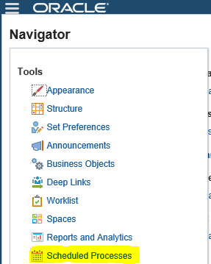](https://3.bp.blogspot.com/-7fkW2snT2Ps/WqDD9GLhn3I/AAAAAAAAB6E/E0AwdxH7VSEbz4WuaBk5o23aY9lCH2SDQCLcBGAs/s1600/fd170.PNG)

 Step2:-  
Click on Schedule New Process  
Type -Job ,  
Name: LOV Search "Subledger Period Close Exceptions Report"  
Choose & Click OK

[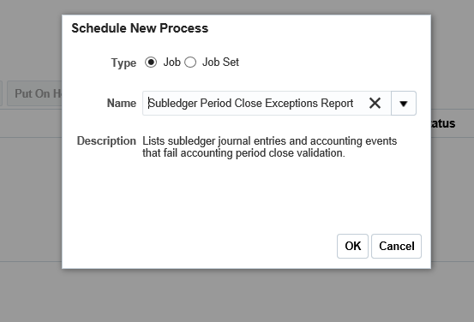](https://1.bp.blogspot.com/-sqzrd6jYKfk/WqDFKtVg7DI/AAAAAAAAB6U/jzK3S8yosm0ALDBWmbUAXaMVeug2l_LrgCLcBGAs/s1600/fd176.PNG)

Step3:-

Review the Output & Ensure all transactions are accounted and reports are showing as per expectation for the month.

We need to correct the Transactions if we got in the report output then after that we can start Close Accounting Period Process.

Step4:- Navigate to the Open/Close Accounting Periods.

Receivables >Task>Receivables Periods>Manage Accounting Periods

[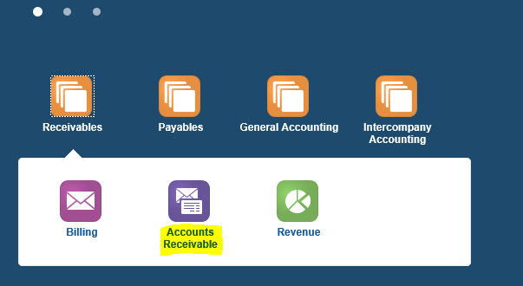](https://3.bp.blogspot.com/-QAMMpWvL6MM/WqDF_GxDpvI/AAAAAAAAB6g/WR3GiD34oP81TxcwYY5g1iXP6BGclLsawCLcBGAs/s1600/fd134.PNG)

Step5:- Open/Close Accounting Periods.

[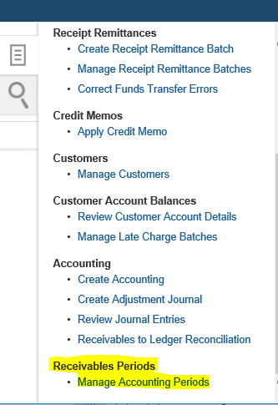](https://1.bp.blogspot.com/-9dnsOD6NRjE/WqDGY_M1qAI/AAAAAAAAB6k/4ljIELpxa4cIw2rZUe078sR1vWTI4WCwACLcBGAs/s1600/fd177.PNG)

Step6:-  Select the Specific ledger for the Period.

Highlighted the period to be Closed and click the Closed Period button.