**Updating Unit List Price in Blanket Sales Agreement in R12.2**

**Updating Unit List Price in Blanket Sales Agreement**

**Exercise 1: Firstly we will try to create a Blanket Sales Agreement.**

Responsibility: Order management Super User.

Navigation: Sales Agreements > Sales Agreement.

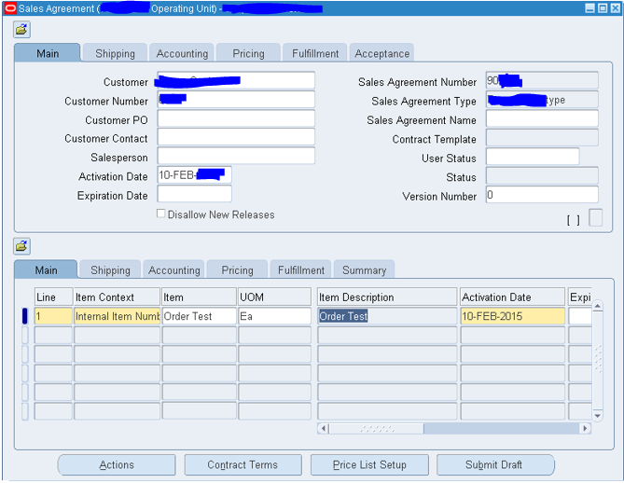

Come to pricing tab in BSA Header and give the price list.

Go to line level and try to give Unit List Price. System will not allow you to enter and says” **This field is protected against update**”.

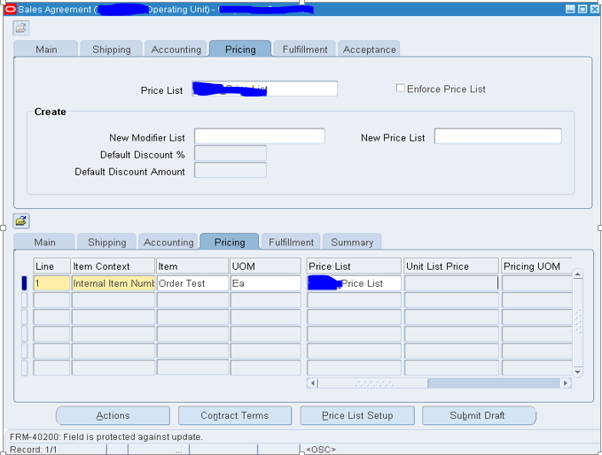

Usually when we try to create a BSA with the Global Price list, system will not allow us to edit the Unit List price in the line level.

Solution:

**Exercise 2: So we will now find out the possible way to get the price updatable.**

Create a Sales Agreement.

Give the customer name and agreement type.

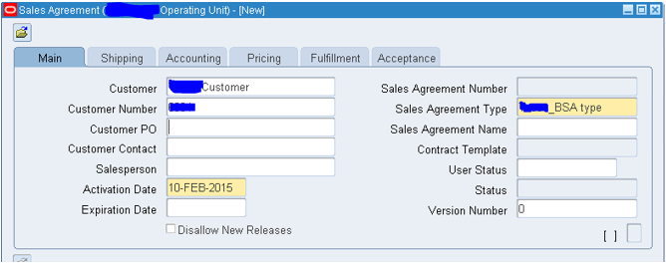

Make sure the Price List is not given in the Pricing tab in BSA header.

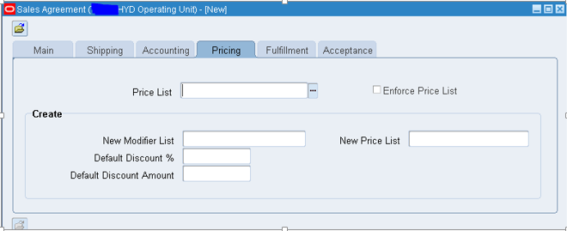

Come to Line level and give the Item and click on **Price List Setup** button in the bottom.

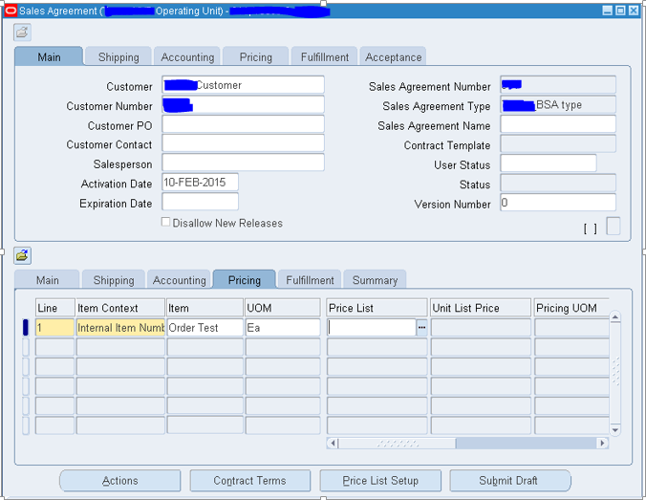

Now the system will be redirected to Advanced Pricing Module as below.

Note the Global field will be unchecked and we can find the operating unit next to that, means the price list what we are creating is not global and limited to our operating unit.

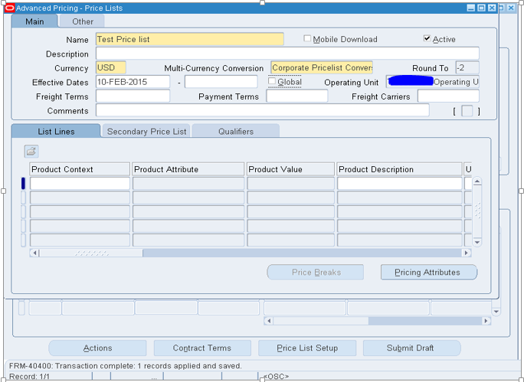

Now come to line level and try to update the unit price and you can now able to update as below.

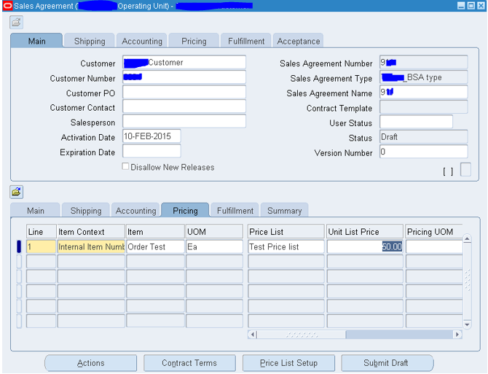

Now you can go ahead and submit the draft and get approved from the customer and the Blanket Sales Agreement is now active and you can release the orders.

