What is a Credit Check?

Credit checking feature of Oracle OM Provides the ability to check that the customer has sufficient credit available with the Organization at the point of order booking, Picking, Packing and Shipping. Automatically apply or release order or order line credit holds using credit check processor program.

Credit exposure = OM Orders which are not closed/Cancelled + Outstanding AR Invoices – Unapplied Receipts

Available Credit = Credit Limit – Credit Exposure

Why Credit Check?

To minimized the financial risk.

**Steps involved in implementing credit check process:**

1. Define credit check rules (OM Resp—Setup—Credit—Define Credit Check Rules)

2. Assign credit check rules to Order type

3. Enable credit check under payment terms used on Sales Order

4. Define customer profile class and assign the customer profile class to customers

Note: Credit check can be enabled at party Level or Customer account level or Bill to site level

1.

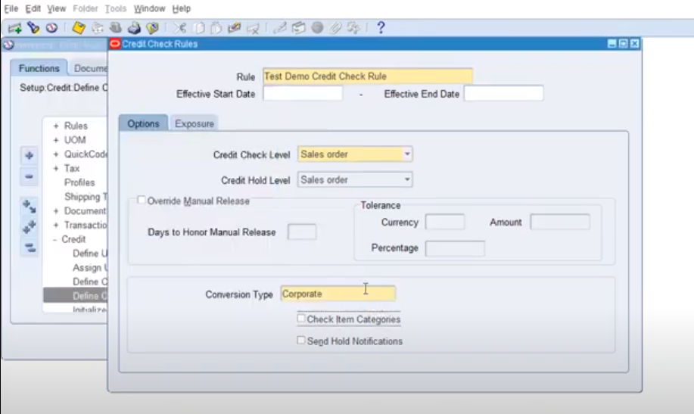

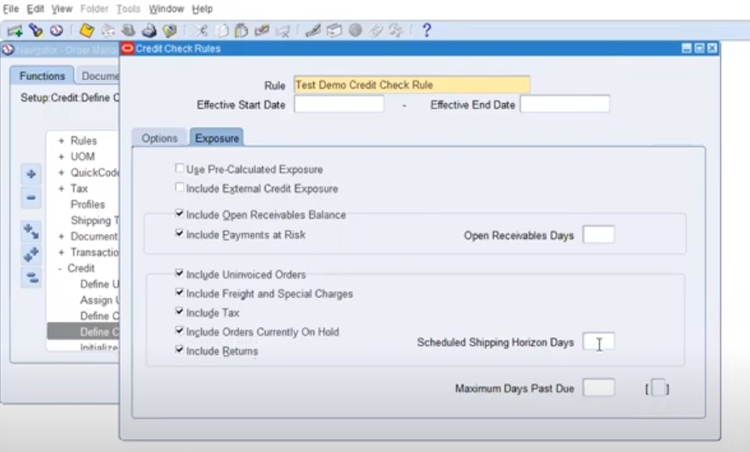

Save it and close.

Step: 2

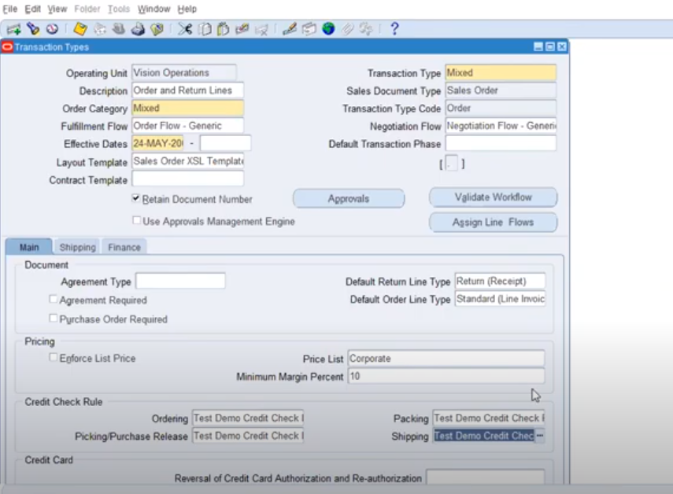

Step: 3

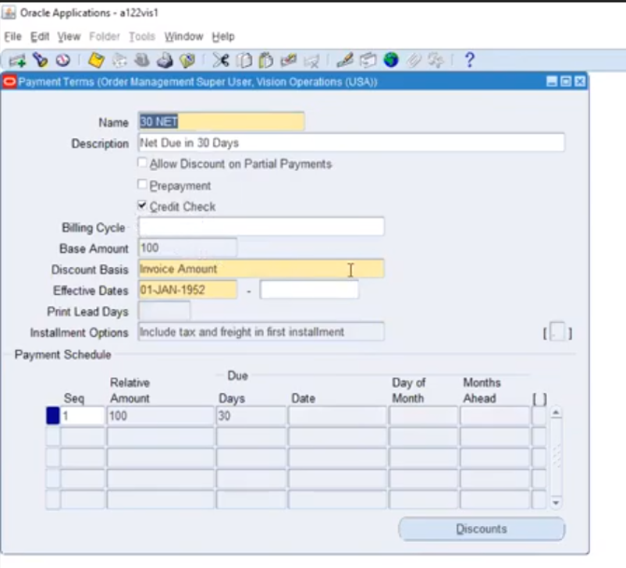

Step 4:

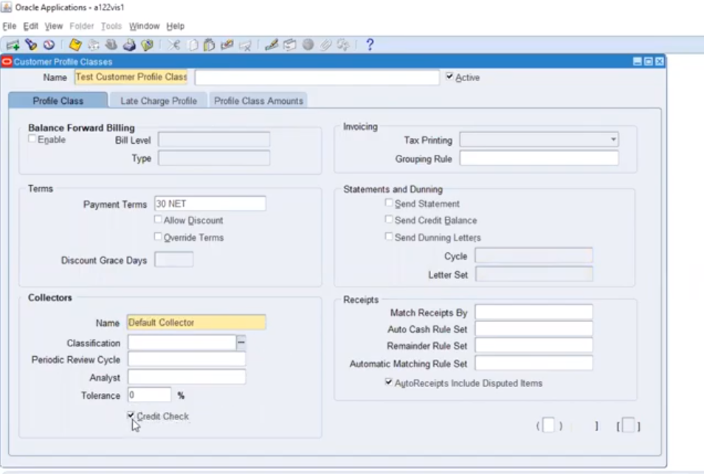

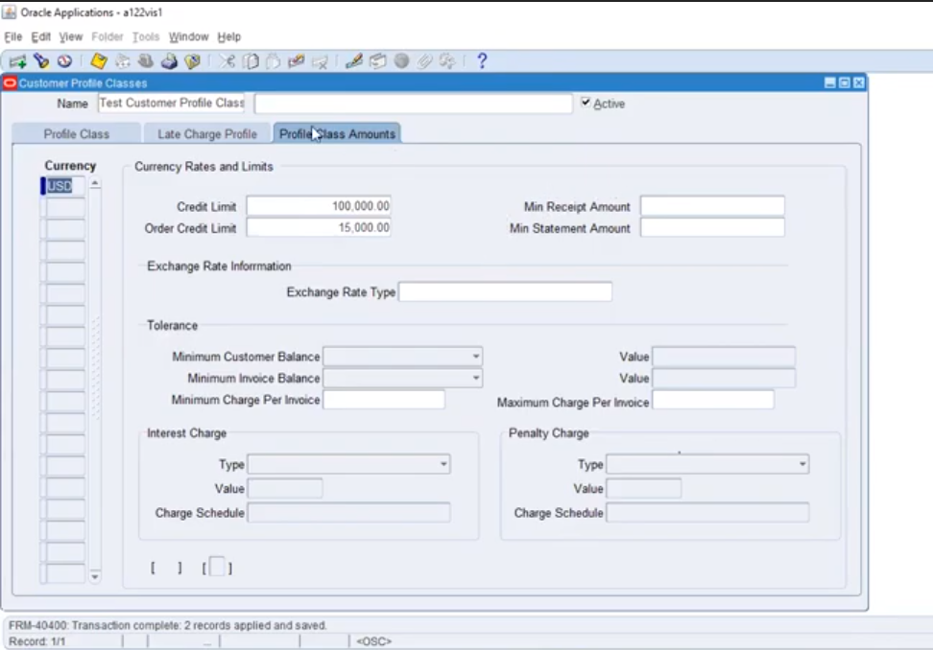

Step:5

Assign customer profile at customer level, credit check is automatically enabled and profile amounts also automatically updated.

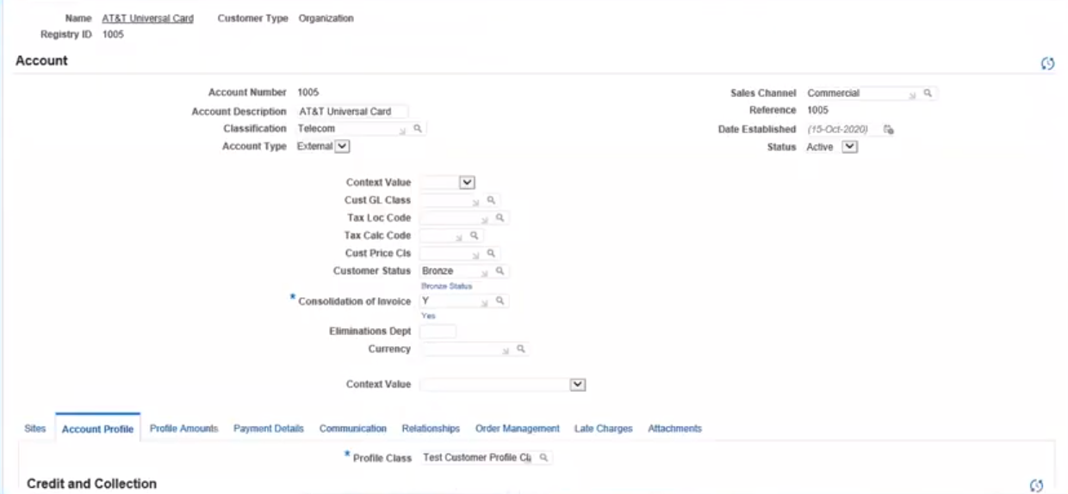

Credit hold we can do in 2 ways: 1.Manual and 2.Program

Program - Credit check processor

This program is used to release the sales orders, which are under credit hold if those sales orders are eligible to process. This will be a scheduled program.

Manual Credit hold apply and release will be provided to few responsibilities:

Define Holds

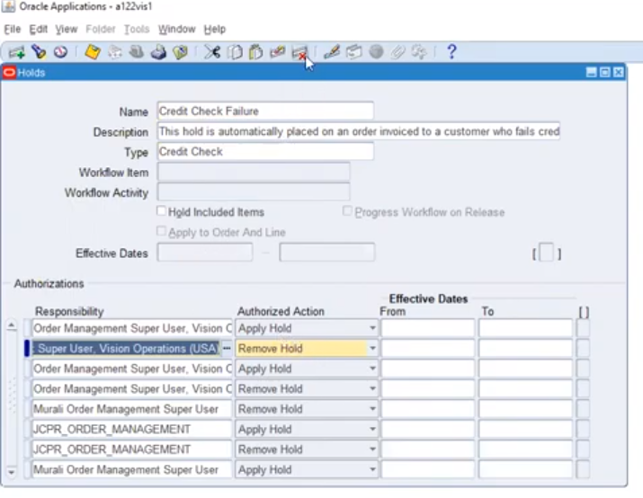

Reports and programs involved in credit check:

1. Some of the reports

- Credit exposure report

- Orders/Lines on credit check holds report

- Outstanding hold report

- Credit order detail report

- Credit limit Usage report

2. Some of the programs

- Credit check processor

- Initialize credit summaries (OE_CREDIT_SUMMARIES Table)