Journal Tax

There are many legal requirements for the enabling the journal tax, which will allow user to enter tax based on certain criteria.

Pre-reqs for creating Journal tax
- Tax Regime
- Taxes
- Tax Status
- Tax Jurisdiction
- Tax rates
- Tax Accounts
- Tax Rules

Setups required for Journal tax
Navigate to Ledgers to enable tax at ledger level
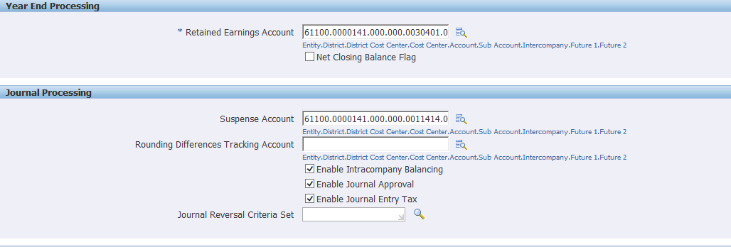
Define Tax options for ledger ->Setup->Tax->Tax options
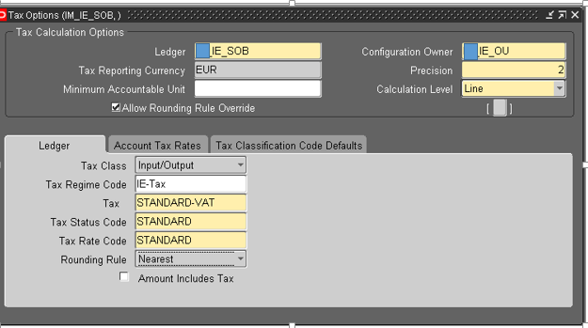
Transaction Process in General Ledger:
Navigation: General Ledger Super User ->Journal ->Enter

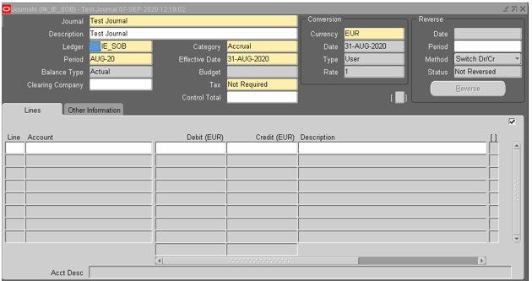
Set tax as required
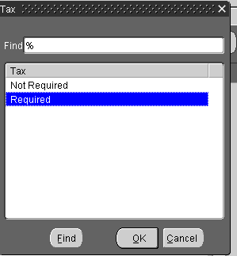

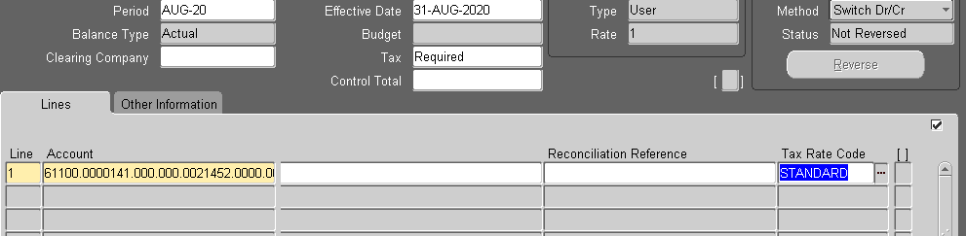

Click on TAX
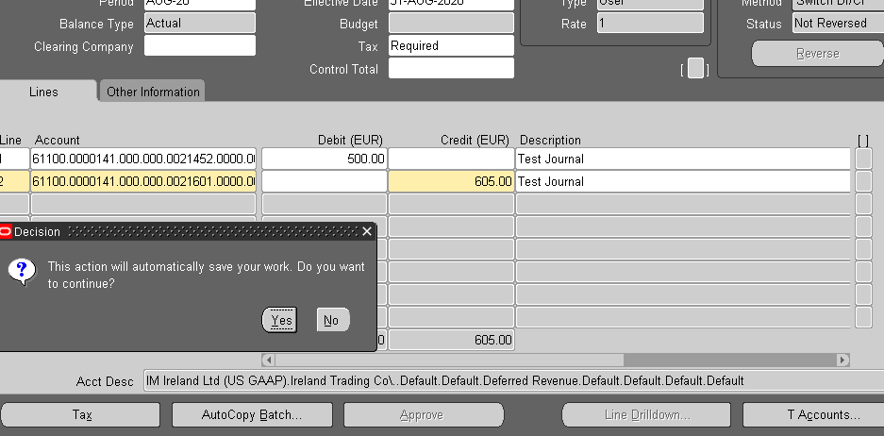

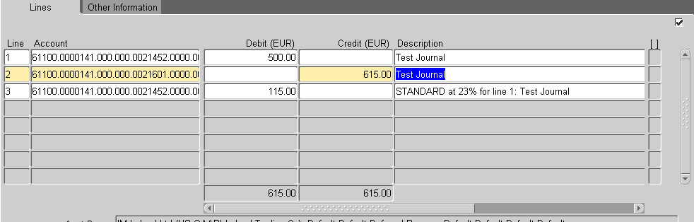
Save and Post the Journal

