**OAF Personalization for IFSC Code in Supplier Screen**

1. Set the values of following profiles to enable Personalization Page link in OAF Pages.

FND: Personalization Region Link Enabled – Yes

Personalize Self-Service Defn -- Yes

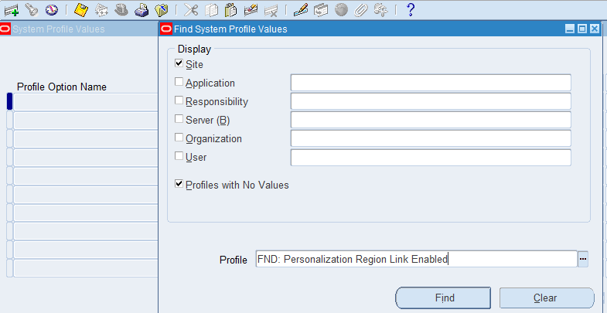

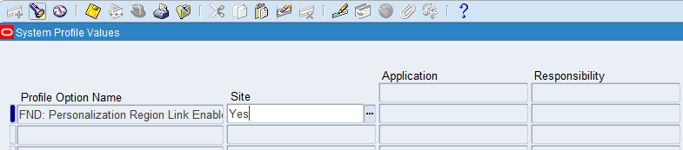

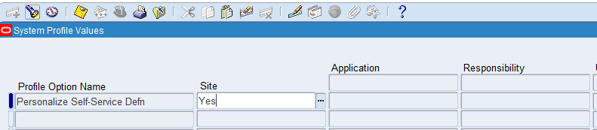

1. Personalization Link will be enabled in OAF Page (If it is visible means no problem otherwise we need to clear cache from Functional Administrative Responsibility)

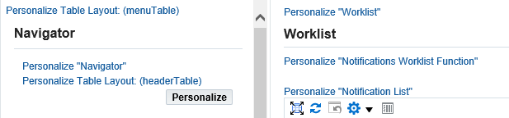

1. Steps to clear cache from Function Administrative Responsibility
2. Navigate to Functional Administrator responsibility and click on “Core Services” tab.
3. Click on “Caching Framework” menu option on the header pane.
4. Click on “Global Configuration” menu option on the left side pane.
5. Click on “Clear All Cache” button.
6. Click on “Yes” button to confirm.
7. Go to required Responsibility

AP Super User IN 🡪 Suppliers 🡪 Entry 🡪

Search with any one supplier

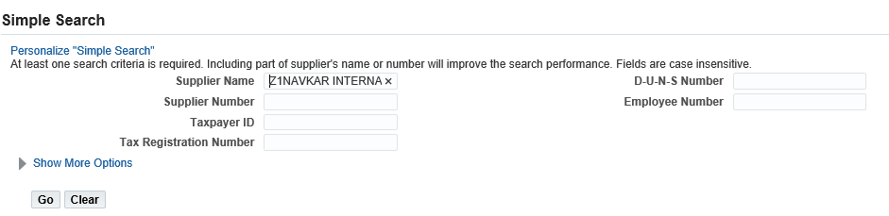

Click on Go button. Supplier details page will be open with details.

Click on Banking Details

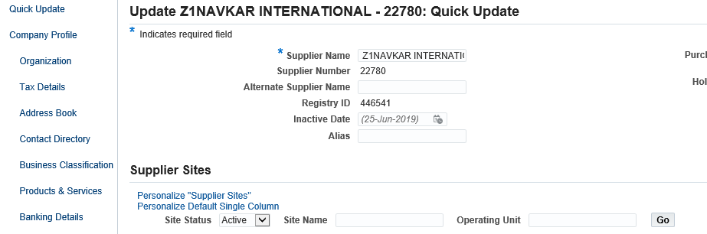

Select Account Assignment level as Site & operating name.

Click on go button.

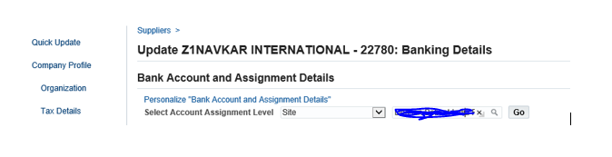

Click on update icon

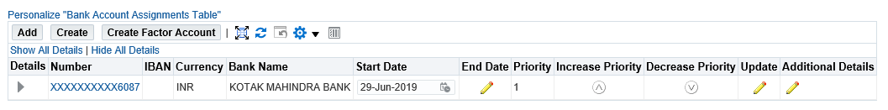

Click on Personalize Bank Account

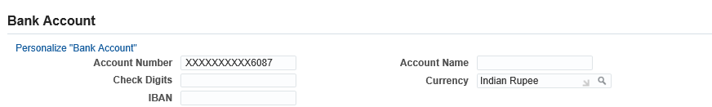

Click on create item icon as below



Enter the values as follows:

Level – Site

Item Style – Message Text Input

ID – IFSCCodeText

Prompt – IFSC Code

View Attribute -- Attribute11

View Instance -- ExtBankAccountsVO1

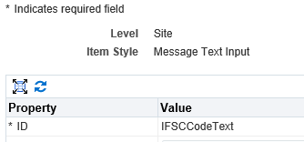





Click on Save.

1. Revert Profile values as No.