Query to Find Form Responsibility in Oracle E-Business Suite (EBS)

Table of Contents
Contents
1. Overview 3
2. Technologies and Tools Used 3
3. Use Case 3
4. Architecture 3
5. Examples 6

Overview

It is utilized to retrieve the responsibility name associated with a form, along with its navigation details within EBS (Oracle E-Business Suite)

Technologies and Tools Used
The following technology has been used to achieve the same.
- Oracle SQL
- Database server

Use Case
N/A.

Architecture
Steps:
Step 1: Find the form name.
If you know some navigation of the form, open the form, and go to
Help>>About Oracle applications
Scroll down to Current form section and copy the form name as shown in the screenshot below.

Step 2: Get the form function id
Use the form name from step 1 in the below query and get the appropriate function_id.

SELECT function_id,USER_FUNCTION_NAME, FUNCTION_NAME, form_name
FROM fnd_form_functions_vl fff, fnd_form ff
WHERE fff.form_id = ff.form_id
and form_name='OEXOEORD'

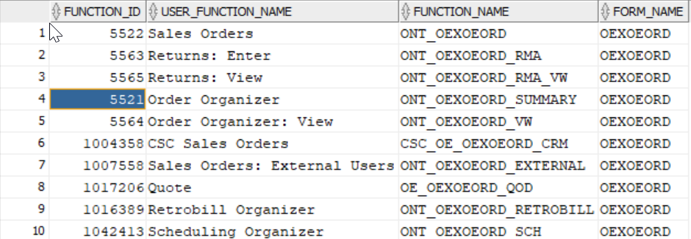

Step 3: Get the responsibility and navigation
Use the function_id obtained in the step2 and run the below query. It gives all the responsibility name along with navigation as shown in screenshot.

SELECT responsibility_name, menu_structure.PATH navigation
FROM ( SELECT LEVEL padding,
menu_id,
RTRIM (reverse (SYS_CONNECT_BY_PATH (reverse (prompt), '>')),
'>')
PATH,
(SELECT menu_name
FROM fnd_menus fm
WHERE fm.menu_id = fme.menu_id)
menu_name,
entry_sequence,
sub_menu_id,
(SELECT menu_name
FROM fnd_menus fm
WHERE fm.menu_id = fme.sub_menu_id)
submenu_name,
function_id
FROM fnd_menu_entries_vl fme
CONNECT BY sub_menu_id = PRIOR menu_id
START WITH function_id = :function_id
ORDER SIBLINGS BY entry_sequence) menu_structure,
fnd_responsibility_vl fr
WHERE menu_structure.menu_id = fr.menu_id
order by 1;

Examples

