NETWORK DYNAMIC ROUTING PROTOCOL

Why Dynamic routing protocol?
During the early days of the network, static routing was in the play. But later at the stage when the network start to grow static routing were being a problem such as configuration overhead, Layer 3 routing loops, unable to perform load balancing/sharing, auto redundancy etc.

Here is where the dynamic routing protocols came into. There are many types of dynamic routing protocols. Like OSPG EIGRP , RIP , BGP RIP
These protocols were able to learn networks automatically and built the routing table, were able to do load balancing and use multiple links across the routers more effectively. Also, any changes in the topology triggers to update the routing table automatically.
We will see a simple scenario here were the auto failover and load balancing is achieved.
Also we can create unequal cost load balancing between two router use the variance command in eigrp We will be using EIGRP (Enhanced Interior gateway routing protocol. It’s a Cisco proprietary dynamic routing protocol)

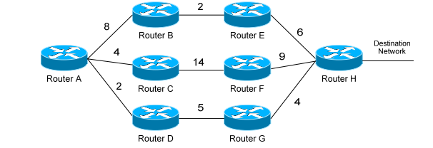

EIGRP Load-Balancing Equal cost
By default, EIGRP will automatically load-balance across equal-metric routes (four by default, six maximum). EIGRP also supports load-balancing across routes with an unequal metric.

EIGRP Load-Balancing UnEqual cost

By default, EIGRP will not load-balance between these two routes, as their metrics are different (11 through Router D, 16 through Router B). We must use the variance command to tell EIGRP to load-balance across these unequal-metric links: RouterA(config)# router eigrp 10 RouterA(config-router)# variance 2 RouterA(config-router)# maximum-paths 6

EIGRP can utilize 5 separate metrics to determine the best route to a destination: • Bandwidth (K1) – Slowest link in the route path, measured in kilobits • Load (K2) – Cumulative load of all outgoing interfaces in the path, given as a fraction of 255 • Delay of the Line (K3) – Cumulative delay of all outgoing interfaces in the path in tens of microseconds • Reliability (K4) – Average reliability of all outgoing interfaces in the path, given as a fraction of 255 • MTU (K5) – The smallest Maximum Transmission Unit in the path. The MTU value is actually never used to calculate the metric

