**Accounting Setup Manager Checklist**

The following table describes the steps to create accounting setups using Accounting Setup Manager. Each required setup step must be completed before you can complete your accounting setup.

|  |  |  |
| --- | --- | --- |
| **Accounting Setup Manager Checklist** | | |
| **Step Number** | **Required** | **Step** |
| Step 1 | Optional | Define Legal Entities  If you plan to record accounting transactions for one or more legal entities, you can use the Legal Entities tab in Accounting Setup Manager or Oracle Legal Entity Configurator to define your legal entities.  **Note:**If you plan to use jurisdictions that do not come seeded, you can define your own jurisdictions using Legal Entity Configurator before you define legal entities. A jurisdiction is the intersection of the physical territory and type of legislation within which judicial authority may be exercised. The jurisdiction is used to assign a territory to a legal entity.   * Overview, *Oracle Financials Implementation Guide* * [Legal Entities Overview](https://docs.oracle.com/cd/E18727_01/doc.121/e13425/T348488T348493.htm#asmuseleov) |
| Step 2 | Required | Create Accounting Setup Structure   1. Assign Legal Entities. 2. Define accounting representations.    * Specify the ledger attributes for the primary ledger.    * Optionally specify the ledger attributes for one or more secondary ledgers.    * Optionally assign one or more reporting currencies. 3. Save accounting structure.   Review setup structure before saving.  Repeat this step for each accounting setup.  **Note:**[Creating Accounting Setup Structures](https://docs.oracle.com/cd/E18727_01/doc.121/e13425/T348488T348493.htm#asmcrst) |
| Step 3 | Required | Complete ledger options.  Define and update journal and transaction processing options for the ledger.  If a secondary ledger is assigned, complete the ledger options for the primary ledger before completing the ledger options for the secondary ledger.  Repeat this step for all ledgers in an accounting setup.  **Note:**[Ledger Options](https://docs.oracle.com/cd/E18727_01/doc.121/e13425/T348488T348493.htm#asmuselop) |
| Step 4 | Conditionally Required | Complete reporting currencies.  If reporting currencies are assigned to the accounting setup when creating the accounting setup structure, it is required to complete the currency conversion options for each reporting currency. Assign reporting currencies to the primary or secondary ledger at any time. Repeat this step for each reporting currency assigned.  **Note:**[Reporting Currencies](https://docs.oracle.com/cd/E18727_01/doc.121/e13425/T348488T348493.htm#asmusercur) |
| Step 5 | Optional | Assign balancing segment values to legal entities.  If you did not assign balancing segment values to legal entities when you created them, you can assign them now. It is strongly recommended that you assign specific balancing segment values to each legal entity to help identify legal entities during transaction processing and reporting. Note: See Balancing Segment Value Assignments |
| Step 6 | Optional | Assign balancing segment values to ledger. If you assigned balancing segment values to legal entities and want to reserve one or more balancing segment values for adjustments or nonlegal entity related transactions, assign specific balancing segment values to the ledger.  For the accounting setup with no legal entity assigned, assign balancing segment values to the ledger to indicate which values are to be used for journal processing in the ledger. If balancing segment values are not assigned to the ledger, then all values will be available. Repeat this step for each ledger.  **Note:**[Ledger Balancing Segment Value Assignments](https://docs.oracle.com/cd/E18727_01/doc.121/e13425/T348488T348493.htm#asmuselbsv) |
| Step 7 | Conditionally Required | Define Subledger Accounting options. If a Subledger Accounting Method is assigned to the ledger, complete the Subledger Accounting options to provide instructions on how to create the accounting from Oracle financial subledgers or external systems to one or more ledgers in General Ledger.  Repeat this step for each ledger that has a subledger accounting method assigned.  **Note:**[Subledger Accounting Options](https://docs.oracle.com/cd/E18727_01/doc.121/e13425/T348488T348493.htm#asmuseslao) |
| Step 8 | Optional | Define operating units. If using an accounting setup that has legal entities assigned, define operating units for your primary ledger.  **Note:**[Operating Units](https://docs.oracle.com/cd/E18727_01/doc.121/e13425/T348488T348493.htm#asmopunit) |
| Step 9 | Optional | Define intercompany accounts. If the accounting setup has legal entities with specific balancing segment values assigned, define intercompany accounts. Intercompany accounts account for intercompany transactions between legal entities.  **Note:**[Intercompany Accounts](https://docs.oracle.com/cd/E18727_01/doc.121/e13425/T348488T348493.htm#asmuseinta) |
| Step 10 | Conditionally Required | Define intracompany balancing rules. If the Intracompany Balancing option for the ledger is enabled, define Intracompany Balancing rules to provide instructions on how to balance journal entries between balancing segment values for the same legal entity or ledger. Repeat this step for each ledger that has this option enabled.  **Note:**[Intracompany Balancing Rules](https://docs.oracle.com/cd/E18727_01/doc.121/e13425/T348488T348493.htm#asmuseintrb) |
| Step 11 | Optional | Define Sequencing. Define accounting and reporting sequencing options for ledgers and reporting currencies. Repeat this step for each ledger.  **Note:**Defining Sequences, *Oracle Financials Implementation Guide* |
| Step 12 | Conditionally Required | Complete primary to secondary ledger mapping. If using secondary ledgers, specify how to convert subledger journals, General Ledger journals, or balances from the primary ledger to the secondary ledger. For example, if the secondary ledger uses a different chart of accounts and currency from the primary ledger, assign a chart of accounts mapping and currency conversion rules.  Perform this step once for each secondary ledger that is assigned to an accounting setup.  **Note:**[Primary to Secondary Ledger Mapping](https://docs.oracle.com/cd/E18727_01/doc.121/e13425/T348488T348493.htm#asmusemap) |
| Step 13 | Required | Complete the Accounting Setup After all required setup steps for both the primary and secondary ledgers of an accounting setup are completed, complete the accounting setup by clicking **Complete** on the Accounting Options page. This button is enabled after all required setup steps have a Complete status. Review the successful completion of the General Ledger Accounting Setup Program in the Concurrent Manager before proceeding.  Perform this step once for each accounting setup.  **Note:**[Completing Accounting Setup](https://docs.oracle.com/cd/E18727_01/doc.121/e13425/T348488T348493.htm#asmusecomset) |
| Step 14 | Optional | Perform additional General Ledger setup steps. Take advantage of additional General Ledger features, such as ledger sets and data access sets, to improve processing efficiency and add additional security to secure access to ledgers.   * [Introduction](https://docs.oracle.com/cd/E18727_01/doc.121/e13425/T348488T348494.htm#asmadglint), Additional General Ledger Setup * General Ledger Setup Flowchart, *Oracle General Ledger User Guide* |
| Step 15 | Required | Assign profile options to responsibilities. To control access to ledgers used by General Ledger users, assign a data access set to the profile option GL: Data Access Set for each General Ledger responsibility. If using subledgers, you should also set the SLA: Enable Data Access Security in Subledgers profile option to control the generation of accounting entries for subledger transactions. This profile option determines whether the General Ledger Data Access Set security mechanism is applied for a subledger application responsibility when viewing, reporting, or creating subledger journal entries associated with a given ledger. The General Ledger Data Access Set security mechanism is always applied for responsibilities associated with the General Ledger application. The profile option enables you to combine data access security with subledger transaction security and therefore control access to subledger journal entries depending on the ledger to which they belong. For example, you can implement a Multiple Organizations Security Profile that allows you to create Oracle Receivables invoices for two different operating units, each associated with different ledgers, but restrict drill-down from the subledger transaction to the associated subledger journal entry based upon the destination ledger contained in the Access Set. If you skip this step, you cannot control access to ledgers and process data optimally in Oracle subledgers and General Ledger.   * Setting General Ledger Profile Options, *Oracle General Ledger User Guide* * Overview of Setting User Profiles, *Oracle Applications System Administrator's Guide* * Setting User Profile Options, *Oracle Applications System Administrator's Guide* |

**Setup Checklist**

The following table provides a more detailed list of Oracle General Ledger setup steps, the Applications area to which each step relates, and whether the step is optional or required. After you log on to Oracle Applications, complete these steps to implement Oracle General Ledger:

|  |  |  |  |
| --- | --- | --- | --- |
| **Step No.** | **Required** | **Step** | **Reference** |
| Step 1 | Required | Define your chart of accounts. See: [Defining Your Chart of Accounts](https://docs.oracle.com/cd/E18727_01/doc.121/e13620/T450006T450009.htm#I_px2Dcoa). | Common Applications |
| Step 2 | Optional | Define Cross-Validation Rules to prevent certain account combinations from being created. | Common Applications |
| Step 3 | Optional | Define a chart of accounts mapping to map two or more charts of accounts. The chart of accounts mapping is used by Accounting Setup Manager to complete the setup steps for secondary ledgers, and it is used by the Global Consolidation System (GCS) to consolidate data between ledgers. | Common Applications |
| Step 4 | Optional | Define Your Descriptive Flexfields See: [Defining Descriptive Flexfields for General Ledger](https://docs.oracle.com/cd/E18727_01/doc.121/e13620/T450006T450009.htm#I_px2Ddff) | Common Applications |
| Step 5 | Optional | If you want to use period types not installed with General Ledger, define your accounting period types. See: [Period Types](https://docs.oracle.com/cd/E18727_01/doc.121/e13620/T450006T450009.htm#I_tx2Dperx2Dpertyp) | Common Applications |
| Step 6 | Required | Define your accounting calendar. Review the Calendar Validation report to note common setup errors.  See: [Defining Calendars](https://docs.oracle.com/cd/E18727_01/doc.121/e13620/T450006T450009.htm#I_tx2Dcal) | Common Applications |
| Step 7 | Optional | If you plan to use average balance processing, define a transaction calendar and valid business days for that calendar. The transaction calendar ensures that journals created in Oracle General Ledger and Oracle Subledger Accounting (SLA), if used, will be posted on valid business days. See: [Defining Transaction Calendars](https://docs.oracle.com/cd/E18727_01/doc.121/e13620/T450006T450009.htm#I_tx2Dadbx2Dtx78cal) | Common Applications |
| Step 8 | Required | Define the currency for your ledger. Also define or enable any reporting currencies you plan to use. See: Oracle General Ledger User's Guide Defining Currencies, *Oracle General Ledger User's Guide* | Common Applications |
| Step 9 | Optional | Define conversion rate types and conversion rates, such as daily rates and historical rates. See: Overview of Multi–Currency Accounting, *Oracle General Ledger User's Guide* | Common Financials |
| Step 10 | Optional | Define additional journal entry sources. If you have enabled average balance processing, specify an Effective Date Rule for each journal source you define. See: [Journal Sources](https://docs.oracle.com/cd/E18727_01/doc.121/e13620/T450006T450009.htm#I_tx2Dsrcx2Djrnlsrc) | Oracle General Ledger |
| Step 11 | Optional | Define additional journal categories. See: [Journal Categories](https://docs.oracle.com/cd/E18727_01/doc.121/e13620/T450006T450009.htm#I_tx2Dcatx2Djrnlcat) | Oracle General Ledger |
| Step 12 | Optional | Define Journal Reversal criteria. See: Automatic Journal Reversal Overview, *Oracle General Ledger User's Guide* | Oracle General Ledger |
| Step 13 | Required | Define an accounting setup using Accounting Setup Manager to combine legal entities, ledgers, reporting currencies, subledger accounting methods, and other setup information.  Before you can enter transactions and journal entries to ledgers, you must complete the ledger options for all ledgers assigned to an accounting setup and the accounting setup status must be complete. See: Creating Accounting Setups Oracle Financials Implementation Guide Define additional journal entry sources and categories. If you have enabled average balance processing, specify an Effective Date Rule for each journal source you define. See: [Journal Sources](https://docs.oracle.com/cd/E18727_01/doc.121/e13620/T450006T450009.htm#I_tx2Dsource)and [Journal Categories](https://docs.oracle.com/cd/E18727_01/doc.121/e13620/T450006T450009.htm#I_tx2Dcateg). | Oracle General Ledger |
| Step 14 | Optional | Define Ledger Sets to group ledgers that share the same chart of accounts and accounting calendar/period type combination to take advantage of processing efficiencies, such as opening and closing periods across ledgers in a ledger set. | Oracle General Ledger |
| Step 15 | Optional | Define data access sets to secure read and write access to ledgers, balancing segment values, and management segment values for one or more ledgers. See: [Data Access Sets](https://docs.oracle.com/cd/E18727_01/doc.121/e13620/T450006T450009.htm#glsudataaccsets) | Public Sector Applications |
| Step 16 | Required | Assign a ledger to the profile option GL Ledger Name for each Oracle subledger. This profile option controls the ledger chart of accounts that each subledger will use for transaction processing. | Oracle General Ledger |
| Step 17 | Required | Assign a data access set to the profile option GL: Data Access Set for each General Ledger responsibility.  See: [Data Access Sets](https://docs.oracle.com/cd/E18727_01/doc.121/e13620/T450006T450009.htm#glsudataaccsets) See: Setting General Ledger Profile Options, *Oracle General Ledger Reference Guide* | Oracle General Ledger |
| Step 18 | Optional | Define Definition Access Sets and assign them to responsibilities. Once you begin securing your definitions, you can assign the Definition Access Sets assigned to your responsibilities. See: [Definition Access Sets](https://docs.oracle.com/cd/E18727_01/doc.121/e13620/T450006T450009.htm#glsudefaccesssets) | Oracle General Ledger |
| Step 19 | Optional | Define account combinations that can be used for data entry if you did not enable Dynamic Insertion for your chart of accounts structure. See: [Defining Accounts](https://docs.oracle.com/cd/E18727_01/doc.121/e13620/T450006T450009.htm#I_tx2Dcombo) | Oracle General Ledger |
| Step 20 | Optional | Define and assign document sequences. See: [Defining Document Sequences](https://docs.oracle.com/cd/E18727_01/doc.121/e13620/T450006T450009.htm#glsudefdocseqs) | Oracle General Ledger |
| Step 21 | Optional | Define Your Employees. (Oracle Human Resources Management System User’s Guide) See: Entering a New Employee | Oracle General Ledger |
| Step 22 | Optional | Setup Journal Approval. See: [Setting Up Journal Approval](https://docs.oracle.com/cd/E18727_01/doc.121/e13620/T450006T450009.htm#I_tx2Djawfx2Dsetup) | Oracle General Ledger |
| Step 23 | Optional | Define one or more of the following optional accounts:   1. Suspense accounts. See: [Suspense Accounts](https://docs.oracle.com/cd/E18727_01/doc.121/e13620/T450006T450009.htm#I_tx2Dsusx2Dsusacc) 2. Statistical Units of Measure.   See: [Defining Statistical Units of Measure](https://docs.oracle.com/cd/E18727_01/doc.121/e13620/T450006T450009.htm#I_tx2Duom) | Oracle General Ledger |
| Step 24 | Required | Define transaction codes if you use Public Sector General Ledger.  See: Setting Up Transaction Codes | Oracle General Ledger |
| Step 25 | Optional | Create summary accounts.  See: [Defining Summary Accounts](https://docs.oracle.com/cd/E18727_01/doc.121/e13620/T450006T450009.htm#I_tx2Dsum) | Oracle General Ledger |
| Step 26 | Optional | Set up Automatic Tax Calculation if you do not have Oracle Receivables and Oracle Payables installed. See: [Setting Up Automatic Tax Calculation](https://docs.oracle.com/cd/E18727_01/doc.121/e13620/T450006T450009.htm#I_tx2Dautotax78x2Dsup) | Oracle General Ledger |
| Step 27 | Optional | Define your automatic posting criteria. See: Posting Journal Batches Automatically, *Oracle General Ledger User's Guide* | Oracle General Ledger |
| Step 28 | Optional | Define encumbrance types. See: Defining Encumbrance Types, *Oracle General Ledger User's Guide* | Oracle General Ledger |
| Step 29 | Optional | Set up Budgets. See: Defining Budgets, *Oracle General Ledger User's Guide* | Oracle General Ledger |
| Step 30 | Optional | If you enabled budgetary control, define one or more budgetary control groups. See: Creating a Budgetary Control Group, *Oracle General Ledger User's Guide* |  |
| Step 31 | Optional | Define Security Rules. See: Defining Security Rules |  |
| Step 32 | Required | Set your General Ledger profile options.  See: Setting General Ledger Profile Options, *Oracle General Ledger Reference Guide* |  |
| Step 33 | Required | Open an accounting period. See: [Opening and Closing Accounting Periods](https://docs.oracle.com/cd/E18727_01/doc.121/e13620/T450006T450009.htm#I_tx2Dopenx2Dper) |  |
| Step 34 | Optional | Set up the Global Consolidation System (GCS). See: Global Consolidation System, *Oracle General Ledger User's Guide* |  |

# What are the Mandatory Setups For Payables

Posted by Raju ERP

**Mandatory setups for Payables :**

The following are the mandatory setups for payables.

**1. Define Financial Options.**

**2. Define Payment terms.**

**3. Define Payment Methods.**

**4. Define Payment Formate.**

**5. Define Pay Group.**

**6. Define Supplier.**

**7. Define Banks.**

**8. Define Distribution Sets (Optional).**

**1. Define Financial Options.**

Use the Financials Options window to define the options and defaults that you use for your Oracle Financial Application(s). Values you enter in this window are shared by Oracle Payables, Oracle Purchasing, and Oracle Assets. You can define defaults in this window to simplify supplier entry, requisition entry, purchase order entry, invoice entry, and automatic payments. Depending on your application, you may not be required to enter all fields.  
Although you only need to define these options and defaults once, you can update them at any time. If you change an option and it is used as a default value elsewhere in the system, it will only be used as a default for subsequent transactions. For example, if you change the Payment Terms from Immediate to Net 30, Net 30 will be used as a default for any new suppliers you enter, but the change will not affect the Payment Terms of existing suppliers.  
  
**Navigation: Payables --> Setup --> Options --> Financial.**

[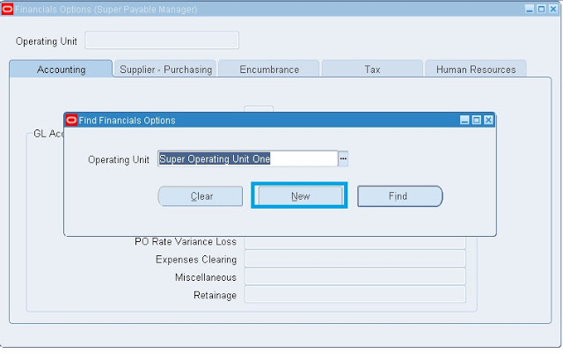](http://1.bp.blogspot.com/-JR4zRiljsYs/UKtNgPa0RXI/AAAAAAAAAIo/l-EoHvTElXs/s1600/Fin1.jpg)

   
 Click on New button.  
  
**Accounting Tab:**  
  
You are required to enter defaults for the Accounting Financials Options in the Accounting region.  
  
**Accounts Like:**  
  
Liability, Prepayment, Discount Taken. 

[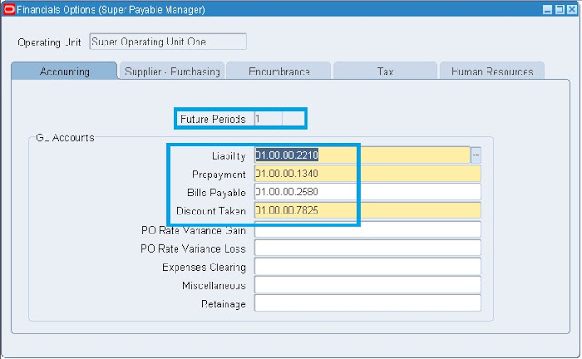](http://2.bp.blogspot.com/-Sfiq_xxNd0s/UKtj7xQFbYI/AAAAAAAAAI8/NyOMlgVQlrQ/s1600/Fin2.jpg)

**Supplier-Purchasing Tab:**  
  
If you do not also have Oracle Purchasing installed, you do not need to enter defaults in the Supplier- Purchasing region.

[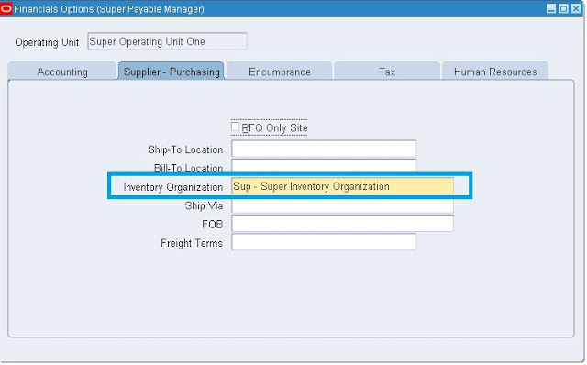](http://1.bp.blogspot.com/-cSateF64ilA/UKtlE4UY0XI/AAAAAAAAAJE/RW1vrAAeACU/s1600/Fin3.jpg)

**Encumbrance Tab:**  
  
If you do not use encumbrance accounting or budgetary control, you do not need to enter defaults in the Encumbrance region. 

[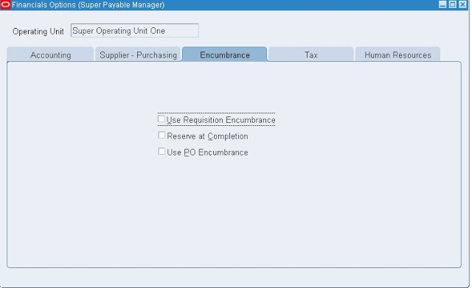](http://1.bp.blogspot.com/-xbir2doint0/UKtlnRlz8cI/AAAAAAAAAJM/jpvVhVdcd1k/s1600/Fin4.jpg)

**Tax Tab:**  
  
If your enterprise does not need to record a VAT registration number, you don't need to enter defaults in the Tax region.

[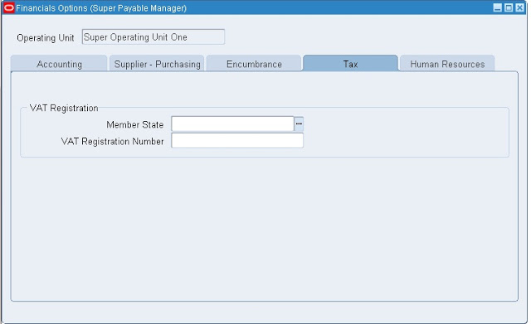](http://1.bp.blogspot.com/-q9njU6gh-ds/UKtmEd_o3HI/AAAAAAAAAJU/-_W4pb7f3Pw/s1600/Fin5.jpg)

**Human Resources Tab:**  
  
If you do not have Oracle Human Resources installed, you are not required to enter defaults in the Human Resources region.

[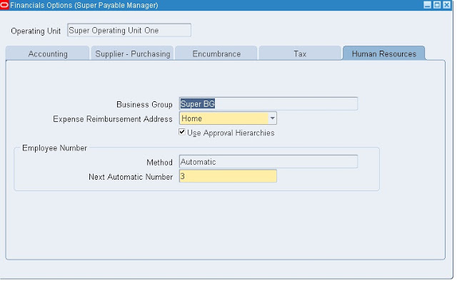](http://3.bp.blogspot.com/-5BeYj3dLKyQ/UKtmpO-4ecI/AAAAAAAAAJc/ipC-pAtjaCY/s1600/Fin6.jpg)

**2. Define Payment terms.**  
  
We define payment terms that you can assign to an invoice to automatically create scheduled payments when you submit Payables Invoice Validation for the invoice. You can define payment terms to create multiple scheduled payment lines and multiple levels of discounts. You can create an unlimited number of payment terms.   
  
  
Payment terms have one or more payment terms lines, each of which creates one scheduled payment. Each payment terms line and each corresponding scheduled payment has a due date or a discount date based on one of the following:

* a specific day of a month, such as the 15th of the month
* a specific date, for example, March 15, 2002
* a number of days added to your terms date, such as 14 days after the terms date
* a special calendar that specifies a due date for the period that includes the invoice terms date. Only due dates can be based on a special calendar. Discount dates cannot be based on a special calendar.

Each payment terms line also defines the due or discount amount on a scheduled payment. When you define payment terms, you specify payment amounts either by percentages or by fixed amounts.  
  
**Navigation: Payables --> Setup --> Invoice --> Payment terms.**  
  
**To define payment terms**

1. In the Payment Terms window, enter a unique payment term Name and a Description. These will appear on a list of values whenever you select payment terms.
2. If you enter Day of Month terms, enter a Cut-off Day.
3. If you enable Automatic Interest Calculation using the Interest Payables Options, enter a unique value in the Rank field.
4. If you want to make this payment term invalid on and after a certain date, enter that date in the To field of the Effective Dates region.
5. Enter each payment terms line.   
   Enter one of the following to determine the portion of an invoice due on the scheduled payment:
   * % Due
   * Amount

In the Due tab, enter one of the following to determine the due date on the scheduled payment line:

* + Calendar
  + Fixed Date
  + Days
  + Day of Month, and Months Ahead

1. If you use discount terms, define payment terms lines in the First Discount , Second Discount, and Third Discount tabs. Define your discounts so that the first discount has an earlier discount date than the second and so on. You can realize only one discount on a payment terms line.

**Note:**You cannot use a special calendar to define discount terms.

Enter one of the following to determine the portion of the invoice to discount on the scheduled payment:

* + % Discount
  + Amount

In the Discount tabs, enter the discount percent.  
Enter one of the following to determine the due date on the scheduled payment line:

* + Due Days
  + Day of Month, and Months Ahead

[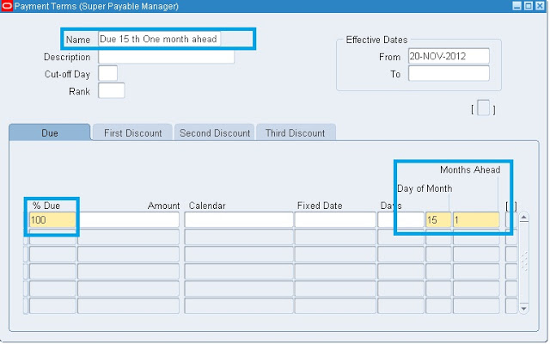](http://1.bp.blogspot.com/-D1N-0TlSDsU/UKtp5j4kAFI/AAAAAAAAAJ4/drmviqD3JrA/s1600/Pay.jpg)

Save.  
  
**3. Define Payment Method:**  
  
A funds disbursement payment method is a medium by which the first party payer, or deploying company, makes a payment to a third party payee, such as a supplier. You can use a payment method to pay one or more suppliers. Oracle Payments supports several payment methods for funds disbursement, including the following:

* Check
* Electronic
* wire
* Clearing

**Check:**   
  
You can pay with a manual payment, a Quick payment, or in a payment batch.  
  
  
 **Electornic:**  
  
Electronic An electronic funds transfer to the bank of a supplier.You create electronic payments either through the e- Commerce Gateway, or by delivering a payment batch file to your bank. For both methods, Payables creates a file during payment batch creation. If you are using the e-Commerce Gateway to create the file of payments, an EDI translator is required to create the EDI Formatted file prior to delivering it to your bank.For electronic funds transfers, the file is formatted and delivered to your ap.out directory for delivery to your bank.  
  
**Wire:**  
  
Wire Funds transfer initiated be contacting the bank and requesting wire payment to the bank of a suplier.A payment method where you pay invoices outside of Payables by notifying your bank that you want to debit your account and credit your supplier’s account with appropriate funds. You provide your bank with your supplier’s bank information, and your bank sends you confirmation of your transaction. Your supplier’s bank sends your supplier confirmation of the payment. You then record the transaction manually.  
  
**Clearing:**  
  
Clearing Payment for invoices transferred from another entity within the company without creating a payment document.Payment method you use to account for intercompany expenses when you do not actually disburse funds through banks. You do not generate a payment document with the Clearing payment method. When you enter the invoice, you enter Clearing for the payment method.You can record a Clearing payment using a Manual type payment only.   
 **Navigation: Payables --> Setup --> Payment --> Payment Administrator.**  
 **Click on Go To Task.**

[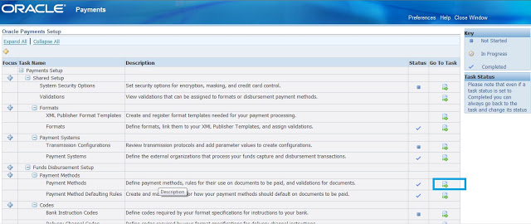](http://1.bp.blogspot.com/-ioZ9y_RclB0/UKtzGxfLNJI/AAAAAAAAAKM/lfGQW7sbVYE/s1600/Pm.jpg)

 Click on Create button.

[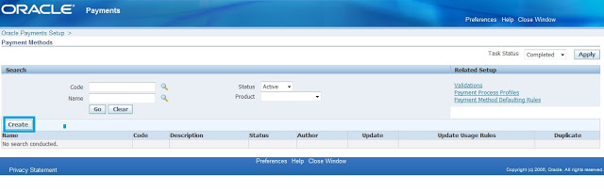](http://2.bp.blogspot.com/-rompAfY87O8/UKtzl5PdLnI/AAAAAAAAAKU/D6kZD785k8I/s1600/Cre.jpg)

Enter the Payment Method name and code and then click on Next.

[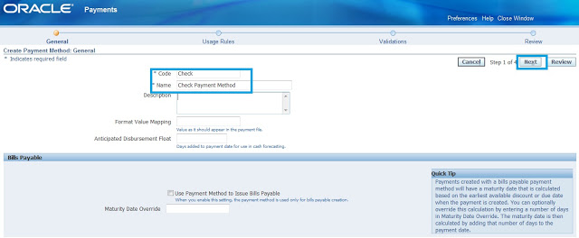](http://1.bp.blogspot.com/-22JmszSxN4o/UKt0h7eTqNI/AAAAAAAAAKc/RfKdYFzZPIc/s1600/Pm1.jpg)

 Select the respective responsibilities which we want shown this payment method in these responsibilities.

[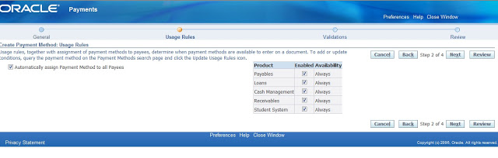](http://2.bp.blogspot.com/-rlWjTthUUbQ/UKt1avw3V6I/AAAAAAAAAKk/6HeptGBX1JY/s1600/Pm2.jpg)

Click on Next, Next, Finsh.

[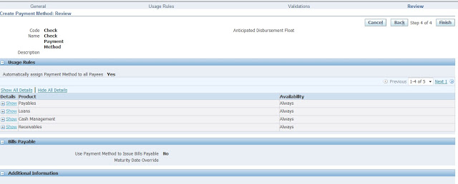](http://3.bp.blogspot.com/-dERn8HDp1LY/UKt2EVcNzEI/AAAAAAAAAKs/C0zFTzipssQ/s1600/Pm3.jpg)

### End to End Configuration of AR in R12

**End to End Configuration of AR in R12**

There are few key steps that are to be configured outside of AR

1. Define Ledger with LE

2. Define Operating Unit and link to Ledger and LE

3. Define atleast one Inventory Item Organization

4. Define Item Validation Organization in Order Management – We can share this menu, if we don’t implement OM

5. Define Tax in EB Tax.

6. Define banks, branches and accounts – Possible to configure through AR, if security is enabled through UMX security wizard

7. Define or Assign key profile option values to AR responsibilities

Define all the following setup using Receivables Manager responsibility:

**Define System Option**

Define system options to customize your Receivables environment. During Receivables setup, you specify your accounts, customer and invoice parameters, and how the Auto Invoice and Automatic Receipts programs will run.

Setup>System>System Option

[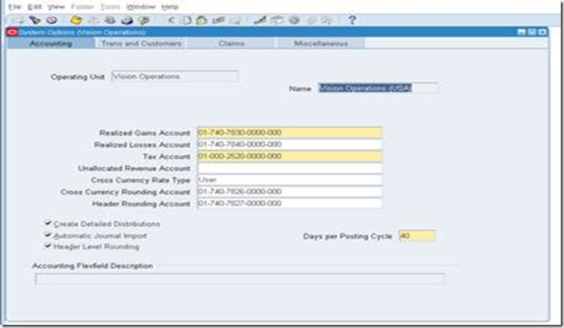](http://lh5.ggpht.com/-zF-rUAOUN9w/Tsq9z1qvEaI/AAAAAAAABHU/_lkiH6yX6w8/s1600-h/clip_image002%25255B6%25255D.jpg)

Define system option for each Operating Unit.

**Define Payment Terms**

Receivables lets you define standard payment terms for your customers to specify the due date and discount date for their open items. Payment terms can include a discount percent for early payment and you can assign multiple discounts to each payment term line. For example, the payment term '2% 10, Net 30' indicates that a customer is allowed a two percent discount if payment is received within 10 days; after 10 days, the entire balance is due within 30 days of the transaction date with no applicable discount.

Setup>Transaction>Payment Term

[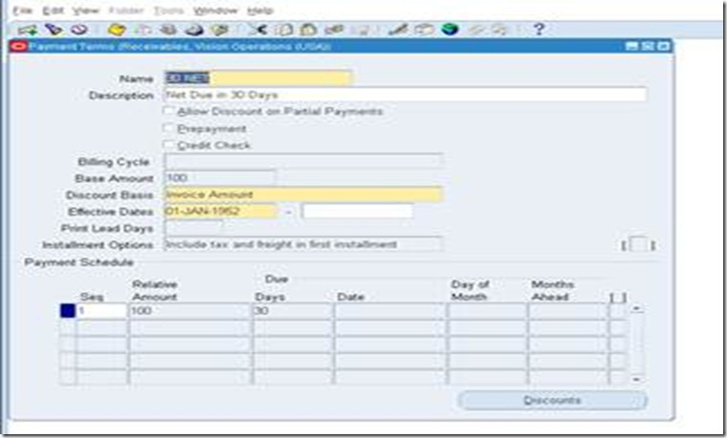](http://lh4.ggpht.com/-9WdVq38dsHo/Tsq91HkxetI/AAAAAAAABHk/V4iV6dRNtRI/s1600-h/clip_image004%25255B5%25255D.jpg)

**Define Transaction Type**

Use transaction types to define the accounting for the debit memos, credit memos, on-account credits, chargebacks, commitments, invoices, and bills receivable you create in Receivables. Transaction types also determine whether your transaction entries update your customers' balances and whether Receivables posts these transactions to your general ledger.

Setup>Transaction>Transaction Type

Define this for each operating unit. Define transaction type for atleast Invoi[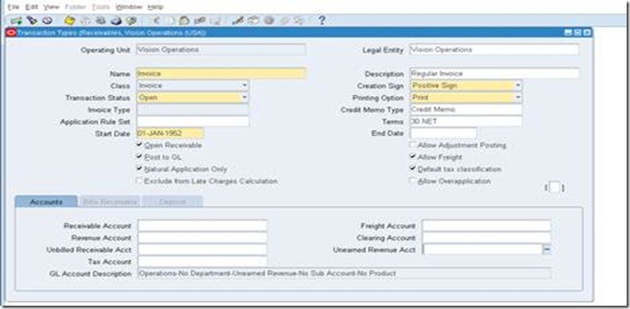](http://lh4.ggpht.com/-VjhhCWmlRhQ/Tsq92-pyHUI/AAAAAAAABH8/eXjOiZy2-js/s1600-h/clip_image006%25255B8%25255D.jpg)ce, Deposit, Credit Memo and Debit Memo transaction classes.

**Define Transaction Source**

Batch sources control the standard transaction type assigned to a transaction and determine whether Receivables automatically numbers your transactions and transaction batches. Active transaction batch sources appear as list of values choices in the Transactions, Transactions Summary, and Credit Transactions windows, and for bills receivable in the Bills Receivable and Bills Receivable Transaction Batches windows.

Setup>Transaction>Source

[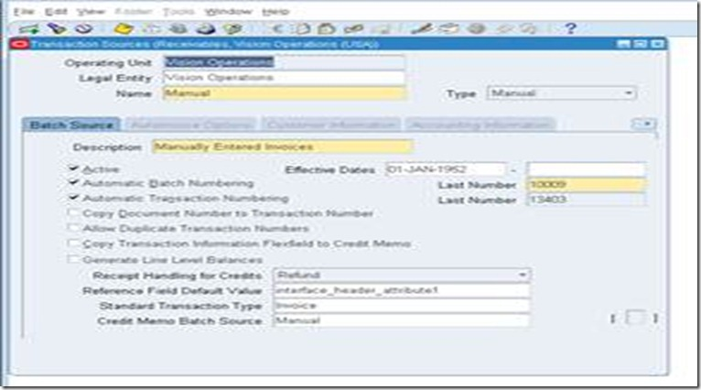](http://lh4.ggpht.com/-xeNWQV3Q57Y/Tsq95dKsEiI/AAAAAAAABII/8rasDixJRaY/s1600-h/clip_image008%25255B5%25255D.jpg)

Define this for each operating unit. Select Type as ‘Imported’, if invoice is to be imported into AR from third party/legacy/external systems.

**Define Memo Lines**

Standard memo lines are lines that you assign to a transaction when the item is not an inventory item (for example, 'Consulting Services'). You can assign memo lines to debit memos, on-account credits, debit memo reversals, chargebacks, commitments, and invoices. Receivables display your standard memo lines as list of values choices during credit memo entry in the Credit Transactions window and during invoice entry in the Lines window. When you create chargebacks and debit memo reversals, you can either use the standard line that Receivables provides or enter your own. You can create an unlimited number of standard memo lines.

Setup>Transaction>Memo Lines

[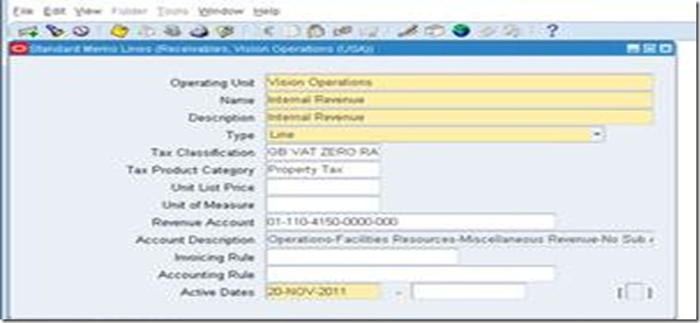](http://lh6.ggpht.com/-oAyefFla2yY/Tsq97KHvp8I/AAAAAAAABIU/0vfHfr9WOXw/s1600-h/clip_image010%25255B7%25255D.jpg)

Define this for each operating unit. This is particularly important, if we implement AGIS.

**Define Accounting Rules**

Define accounting rules to create revenue recognition schedules for your invoices. Accounting rules determine the number of periods and percentage of total revenue to record in each accounting period. You can use accounting rules with transactions that you import into Receivables using Auto Invoice and with invoices that you create manually in the Transaction windows. You can define an unlimited number of accounting rules.

This is generally applicable to project based invoices, property invoices etc.

Setup>Transaction>Accounting Rules

[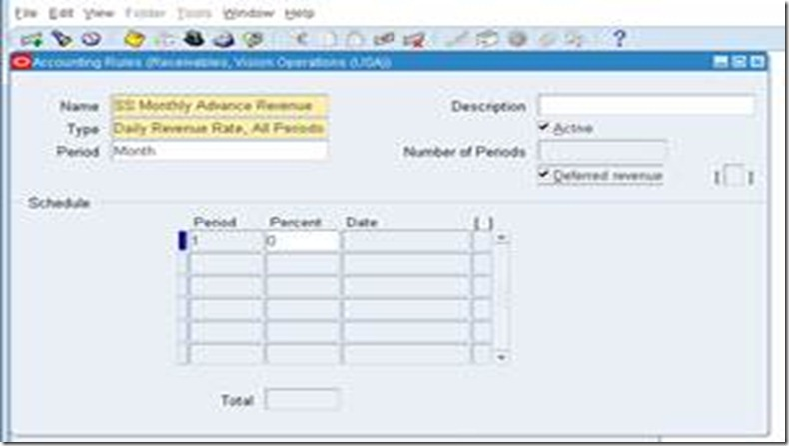](http://lh5.ggpht.com/-KDPACLo0SPk/Tsq99AemtTI/AAAAAAAABIo/0YIiHauF2as/s1600-h/clip_image012%25255B7%25255D.jpg)

**Define Auto Accounting**

Define Auto Accounting to specify how you want Receivables to determine the default general ledger accounts for transactions that you enter manually or import using Auto Invoice. Receivables creates default accounts for revenue, receivable, freight, tax, unearned revenue, unbilled receivable, late charges, bills receivables accounts, and Auto Invoice clearing (suspense) accounts using this information.

Setup>Transaction>Auto Accounting

[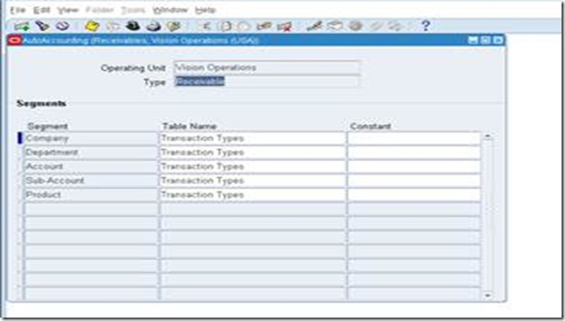](http://lh5.ggpht.com/-4dSZBZO3bJM/Tsq9-sdYY7I/AAAAAAAABI4/D3LU0RE5Fsc/s1600-h/clip_image014%25255B9%25255D.jpg)

Define this for each operating Unit. Define this atleast for revenue, receivable, freight, tax, unearned revenue, unbilled receivable, bills receivables accounts, and Auto Invoice clearing.

Tax code will default from EB Tax, which can be updated/modified here in this auto accounting window.

**Define Approval Limit**

Use the Approval Limits window to define approval limits for Adjustments, Receipt Written off, Credit memo refund and Credit memo

Setup>Transaction>Approval Limit

[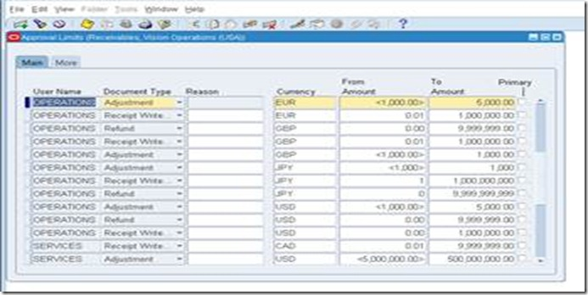](http://lh4.ggpht.com/-2NRsFsZzSDc/Tsq-AO2VmzI/AAAAAAAABJI/QR9ZbtaswlE/s1600-h/clip_image016%25255B5%25255D.jpg)

Define this for each user.

**Define Receivables Activities**

Define receivables activities to default accounting information for certain activities, such as miscellaneous cash, discounts, late charges, adjustments, and receipt write-off applications.

Setup>Receipts>Receivables Activities

[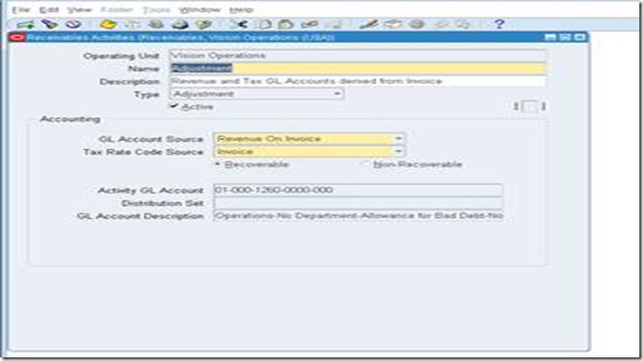](http://lh4.ggpht.com/-VvtYYfPfkv0/Tsq-BpxryDI/AAAAAAAABJY/F7XusAxMVJc/s1600-h/clip_image018%25255B5%25255D.jpg)

Define this for each operating unit. This can be configured only after EB Tax configuration.

**Define Auto Cash Rule set - Optional configuration**

Define Auto Cash Rule Sets to determine the sequence of Auto Cash Rules that Post Quick Cash uses to update your customer's account balances. You specify the sequence and the Auto Cash Rules for each Auto Cash Rule Set. The Auto Cash Rule Sets you define display as list of values choices in the Customers, Customer Addresses, Customer Profile Classes, and the System Options windows. Post Quick Cash first checks the customer site, then the customer profile class, and finally at the system options level to determine the Auto Cash Rule Set to use.

Setup>Receipts>Auto Cash Rule Set

[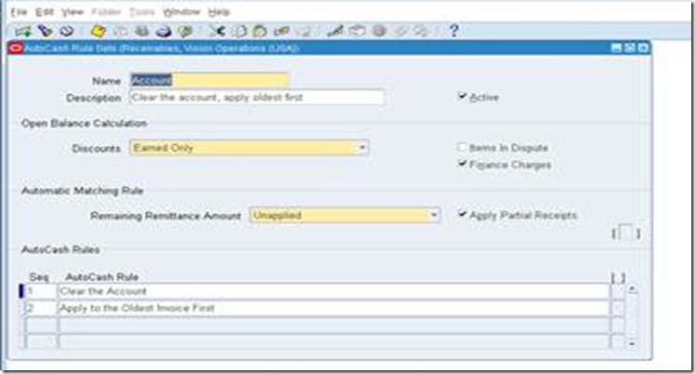](http://lh4.ggpht.com/-SJbWNp-2Z90/Tsq-DCPR_fI/AAAAAAAABJo/_mS-_MaTjnQ/s1600-h/clip_image020%25255B7%25255D.jpg)

**Define Application Rule Set – We can use seeded configuration**

Use the Application Rules Sets window to review existing and define new application rule sets. Application rule sets specify the default payment steps for your receipt applications and how discounts affect the open balance for each type of associated charges. By defining your own application rule set, you can determine how Receivables reduces the balance due for a transaction's line, tax, freight, and late charges.

Setup>Receipt>Application Rule Set

[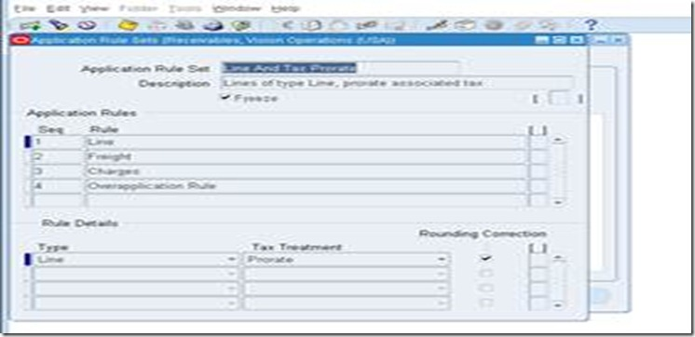](http://lh4.ggpht.com/-w-GpWLFURTY/Tsq-E0Gi1vI/AAAAAAAABJ4/SnXeGMwaB1A/s1600-h/clip_image022%25255B6%25255D.jpg)

**Define Receipt Classes**

Define receipt classes to determine the required processing steps for receipts to which you assign receipt methods with this class. These steps include confirmation, remittance, and reconciliation. You can specify any combination of these processing steps with one exception: if you confirm and reconcile, then you must also remit. If you enter No for all three of these steps, Receivables automatically creates receipts assigned to this receipt class with a status of Cleared.

Setup>Receipt>Receipt Classes

[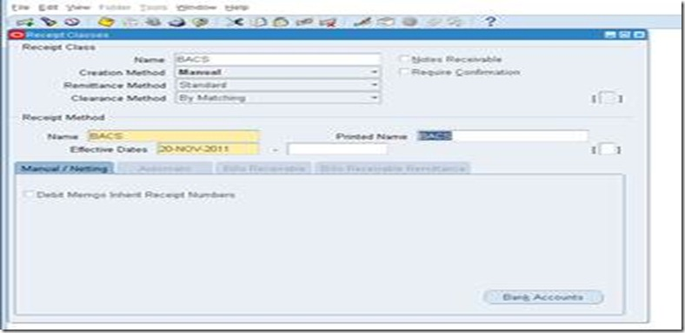](http://lh5.ggpht.com/-8IBUut-x2Ro/Tsq-G3NbuFI/AAAAAAAABKE/77aoEU4CcY4/s1600-h/clip_image024%25255B7%25255D.jpg)

Define this for each operating unit. Only header window is not OU based but bank accounts window are OU specific.

This requires some experience to use this configuration. Basic configuration is simple but it is key configuration to handle various receipts like Credit Card integration, Auto lock box, Bill of Exchange, and Factoring. This requires very good practice and knowledge on Function Capturing Process as well.

**Define Receipt Sources**

Define receipt batch sources to provide default values for the receipt class, receipt method, and remittance bank account fields for receipts you add to a receipt batch. You can accept these default values or enter new ones. Receipt batch sources can use either automatic or manual batch numbering.

Setup>Receipt>Receipt Sources

[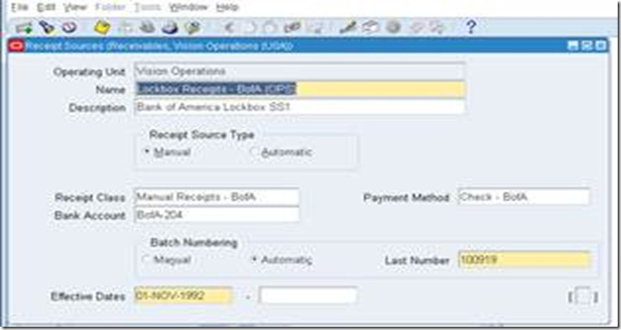](http://lh4.ggpht.com/-1vpA5i3f3fw/Tsq-IHghIkI/AAAAAAAABKY/QCmmhkr0PZs/s1600-h/clip_image026%25255B5%25255D.jpg)

Define this for each operating unit. This is for grouping of receipt class, payment method and bank account.

**Define Collector**

Receivables let you define collectors and assign them to a profile class, or directly to a customer account or site. When you assign a collector to a profile class, that collector becomes the collector for all customers assigned that profile class. You can modify collector assignments for your customers in the Customers pages, and for your profile classes in the Customer Profile Classes window.

Setup>Collections>Collector

[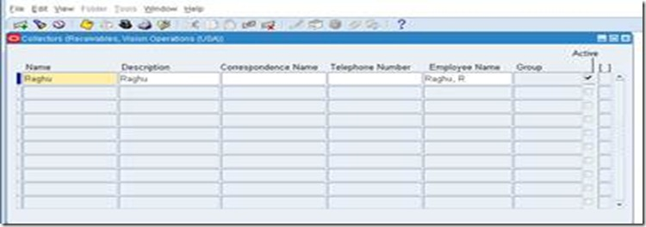](http://lh4.ggpht.com/-oidgB6AYF-Q/Tsq-JHL1ElI/AAAAAAAABKo/KEEiTPUJnac/s1600-h/clip_image028%25255B5%25255D.jpg)

Employee needs to be configured and Collector setup is to be done in CRM.

**Define Aging bucket**

Aging buckets are time periods you can use to review and report on your open receivables. For example, the 4-Bucket Aging bucket that Receivables provides consists of four periods: -999 to 0 days current, 1 to 30 days past due, 31-61 days past due, and 61-91 days past due. When you create your Collections reports, you can specify an aging bucket and 'as of date', and Receivables will group the transactions and their amounts in the appropriate days past due period.

Setup>Collection>Aging Buckets and Interest Tiers

[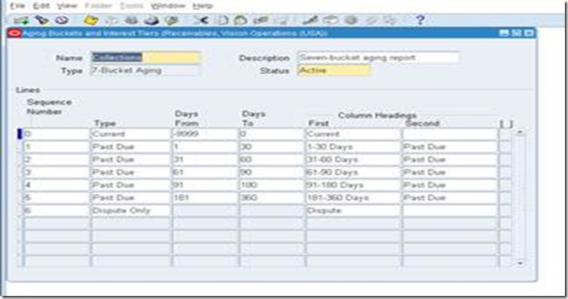](http://lh3.ggpht.com/-I2um5rUAyIA/Tsq-LKW0RQI/AAAAAAAABK0/BhBIM3w0re4/s1600-h/clip_image030%25255B6%25255D.jpg)

**Define Statement Cycles**

Define statement cycles to determine when to send statements to your customers. You enter statement cycles when you define or modify individual customer and site profile classes in the Customer Profile Classes window.

Setup>Print>Statement Cycles

[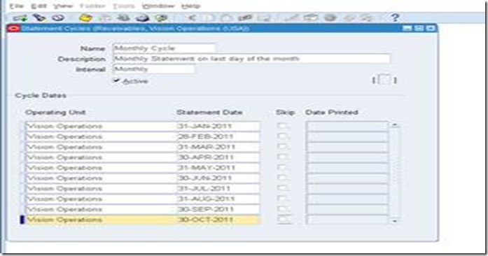](http://lh5.ggpht.com/-RZTZCtVh0Vo/Tsq-MhpMjwI/AAAAAAAABLE/ftCSwjYX0rg/s1600-h/clip_image032%25255B5%25255D.jpg)

Define this for each operating unit. Customer statement will use this cycle.

**Define standard message – Optional**

Define standard messages to provide the text that Receivables prints on the bottom of your customer's statements, debit memos, and interest invoices. You can use messages to inform your customers of special promotions or to make your printed documents more personal.

Setup>Print>Standard message

[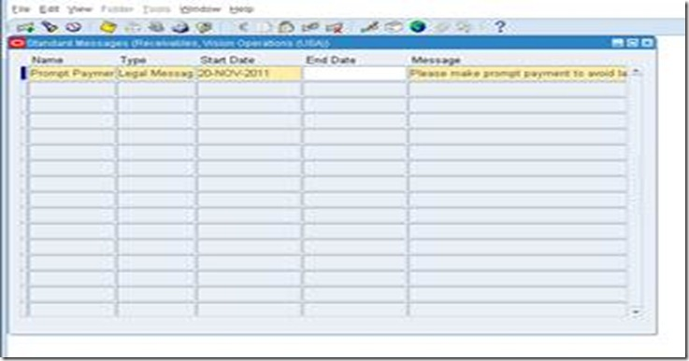](http://lh3.ggpht.com/-1AVdiXZ7dfQ/Tsq-Nw-pI9I/AAAAAAAABLU/56mImaOsagE/s1600-h/clip_image034%25255B5%25255D.jpg)

This message can be used in Customer Statement.

**Define Profile Class**

Use Customer Profiles to group customer accounts with similar creditworthiness, business volume, payment cycles, and late charge policies. For each profile class you can define information such as credit limits, payment terms, statement cycles, invoicing, and discount information. You can also define amount limits for your late charges and statements for each currency in which you do business.

Customers>Profile Classes

[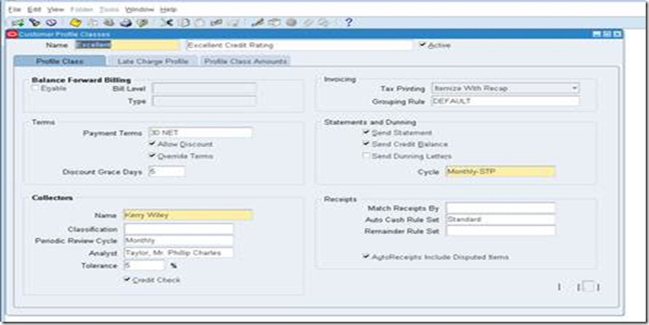](http://lh6.ggpht.com/-EX6VgMiYmcQ/Tsq-PXx-FmI/AAAAAAAABLk/KeDxINMvGkw/s1600-h/clip_image036%25255B8%25255D.jpg)

This is important for consolidated billing, late charges, profile class based strategy in collections and very important configuration for business in real time.

**Define Customers** – Initially customers will be migrated from external/legacy/older version of Oracle EBS.

**Define Remit to address**

Setup>Print>Remit to address

[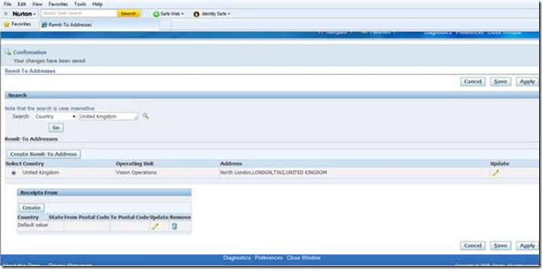](http://lh4.ggpht.com/-4lNeUJAhvF4/Tsq-RE5Z7II/AAAAAAAABL4/hMjRWUxV39U/s1600-h/clip_image038%25255B6%25255D.jpg)

**Open or Close AR accounting period**

Open and close accounting periods in your calendar to control the recording of accounting information for these periods. Receivables lets you open future accounting periods while your current period is still open. Receivables also lets you reopen previously closed accounting periods and enter receivables activities without transferring transactions to the general ledger when you set your accounting periods to 'Future.'

Control>Accounting>Open or Close periods

[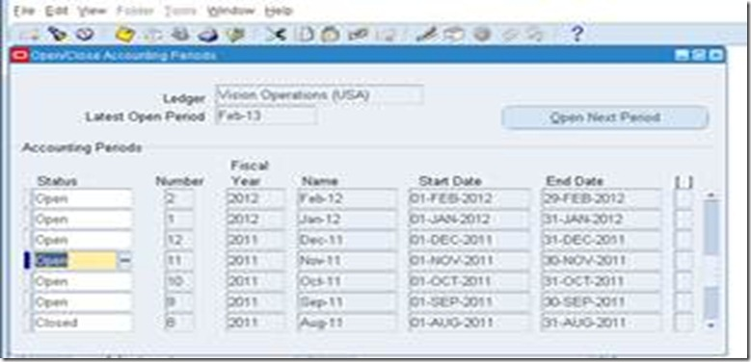](http://lh6.ggpht.com/-uIijSFbO4Zg/Tsq-Sj-VvoI/AAAAAAAABME/l8-zMRPfbPc/s1600-h/clip_image040%25255B5%25255D.jpg)

**** This is ledger based. Open / Close the period in one OU will Open / Close the period in another OU as long as bot the OU shares the same Ledger.

Setup Steps – Key Flexfields Flexfield: Client defined fields. Clients determines the structure/order of the fields, the characteristics of the values to be housed, and the list of values users will select. Two types of

Flexfields: 1. Key – required, must be defined by client [data housed in segments on tables] 2. Descriptive – optional, used to maintain/house additional data that Oracle does not house [data housed in attributes on tables]

Assets has three Key Flexfields:

1. Category Flexfield

2. Location Flexfield

3. Asset Key Flexfield

Setup Steps - Key Flexfields Preformed in the General Ledger Must be defined prior to other subledgers setting up Can have up to 30 segments, 25 characters each segment

Step 2 - Category Flexfield [Required]:

Only one structure supported Category flexfield serves as the holder of default rules (life, method, prorate & accounts) for each of your corporate and tax books

One segment must serve as a ‘Major’ segment Usually Tax Driven - Consult tax department when defining Can have up to 7 segments, 30 characters each segment (recommend 2 or 3 segments)

Combination of segment values plus separators must be 25 characters or less

Once used, unable to change setup

Step 3 - Location Flexfield [Required]:

Purpose: Group assets that have the same physical location

Only one structure supported

Main function is for Property Tax as opposed to a true ‘Asset Tracker’

One segment must serve as ‘State’ segment – used for property tax reporting

Define structure that can be easily maintained

Can have up to 7 segments, 30 characters each segments

Determine if your will allow Dynamic Insertion

Step 4 - Asset Key Flexfield [Required:

Purpose: Group assets without financial impact

Only one structure supported

Group like assets for enhanced reporting S

pecific to each implementation

No financial impact on the system

If not using, one segment required for setup (Define without validation)

Can have up to 10 segments, 30 characters each segment

Once used, unable to change setup

Step 5 - System Controls [Required]:

Company Name - Select a company name that will appear on all Oracle Assets reports

Oldest Date Placed in Service - Required to enter the date of the oldest asset in your database (NOTE: no assets can be added prior to this date)

Automatic Asset Numbering - If converting from a legacy system, select a starting number greater than the number of legacy assets (Alpha-numeric field)

Step 6 – Location Combinations [Required / Optional]:

Required if:

Dynamic insertion not allowed, OR Converting legacy assets via a sql load script into Mass Additions Interface table

Not Required if:

Dynamic insertion is allowed, AND Converting legacy assets via WebADI

Step 9 – Fiscal Years [Required]:

Define the fiscal years for your company

Begin Fiscal Years in the year of the oldest date of your asset defined in System Controls

Define the first year, save, then use arrow down to create additional years

Step 10 – Calendars [Required]:

Define the calendars to be used for calculating depreciation

Define the first year, save, then use arrow down to create additional years

Period Name must be 100% equal to the GL Period Name (including case sensitive)

Two-digit year versus Four-digit year naming convention

Step 11 – Journal Entry Source [Optional]:

Oracle has predefined values

Define, if needed, additional values to include in LOV

Used to identify the source of the journal created in GL

Step 12 – Journal Entry Categories [Optional]:

Oracle has predefined values

Define, if needed, additional values to include in LOV

Used to identify the transaction type of the journal created in GL

Step 13 – Book Controls [Required]:

Define required Depreciation Books (Corporate, Tax, or Budget)

Define rules for the depreciation book (Calendar, Accounting Rules, Natural Accounts & Tax Rules)

Define default accounts to be used for retirements (Gain / Loss)

Step 14 – Subledger Accounting (SLA) / Account Generator [Optional]:

Define how Oracle Assets will create account combinations for transactions

Default rules: Balancing Segment – Assignments Accounts – Category, Book, or Assignments

Determine if entries need to be booked at a lower level (i.e. Cost Center)

Account Generator:

Asset Level – depreciation expense

Book Level – gain / loss accounts, intercompany, deferred depreciation

Category Level – asset cost, clearing, accumulated depreciation, CIP accounts

SLA: Modify Journal Lines Definitions (Event Class and Event Type)

Step 15 – Depreciation Methods [Optional]:

Oracle has predefined Methods and Life combinations

Define, if needed, additional Methods and Life combinations

Oracle supports: life-based, flat-rate, and units or production

Step 16 – Depreciation Ceilings [Optional]:

Used to limit an asset’s depreciation

Define, if needed, Cost or Expense ceilings

Step 17 – Investment Tax Credits [Optional]:

Used in the United States for luxury autos purchased prior to 1987

ITC reduce the actual tax amount

Step 18 – Prorate Conventions [Required]:

Define from the date of the oldest asset defined in System Controls

Used to determine Prorate Date

Prorate convention determines the annual depreciation for the first fiscal year

Retirement convention determines the annual depreciation for the retirement year

Step 19 – Price Indexes [Optional]:

Used in Australia

Used by the Revalued Asset Retirement Report to determine the revalued asset cost, to use while calculating gains and losses

Step 20 – Unit of Measure Classes [Optional]:

Define if using Units of Production depreciation methods

Classes group units of measure

Step 21 – Unit of Measure [Optional]:

Define if using Units of Production depreciation methods

Step 22 – Asset Categories [Required]:

Define asset category combinations

Link Asset Categories to Depreciation Books defined in Book Controls

Assign default accounts – to be used by SLA or Account Generator to create journals

Define default depreciation rules – Method, Life, Prorate Conventions