Introduction/ Issue

This document will explain how user can upload fixed asset using web Adi process.
How to Effectively Upload Data To Oracle Applications With Web ADI

Why we need to do / Cause of the issue:

WEBADI for Asset upload in EBS

Review the setup of categories –Auto & Trucks Capital lease
Choose your Book - CO_CORP_SERV_US

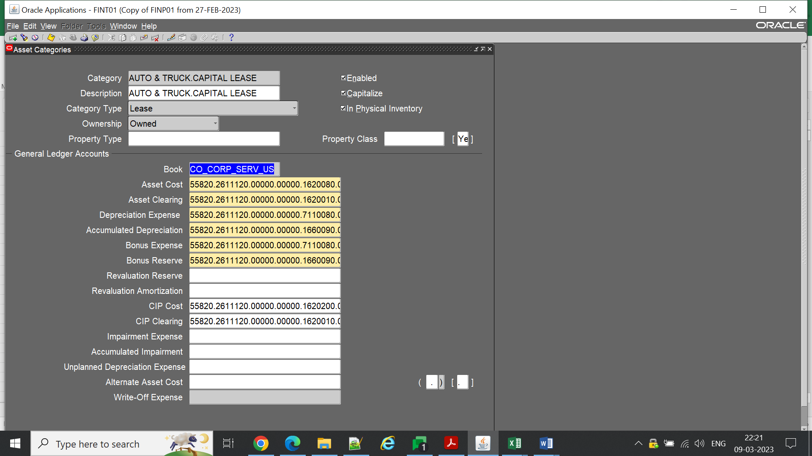

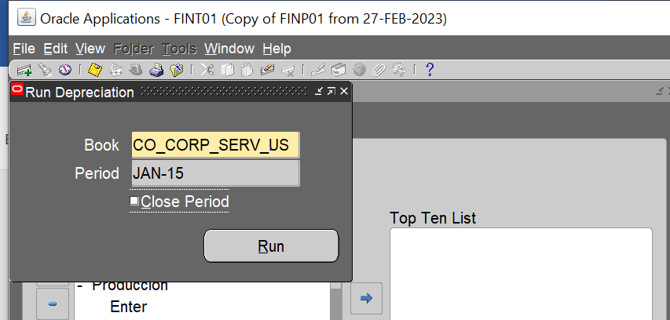

Last period open was jan-15
NavigationAdditions Integrator
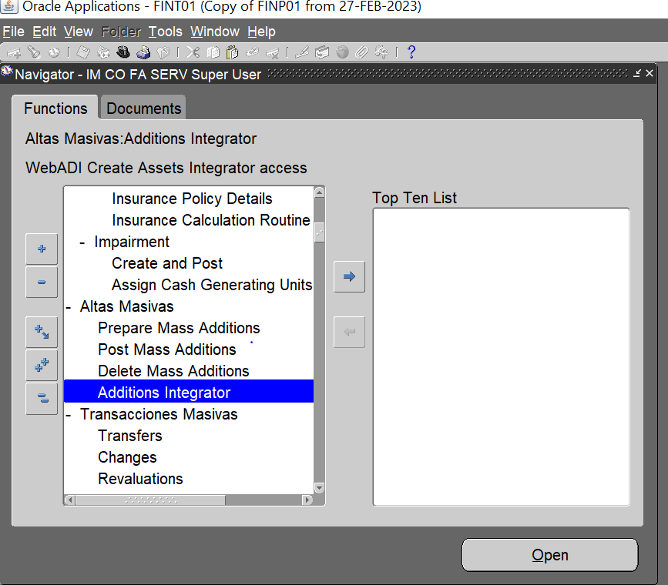

Choose the –Iron New Assets Uploads Colombia

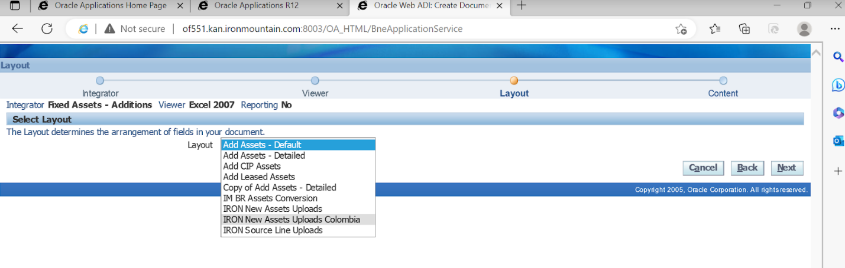

Webadi Template

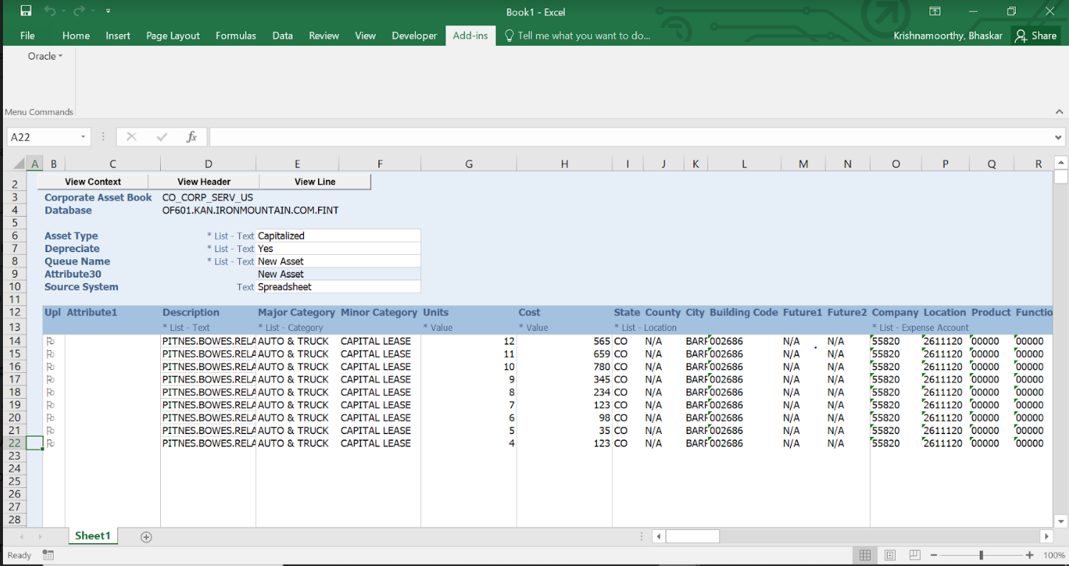

Asset loaded successfully

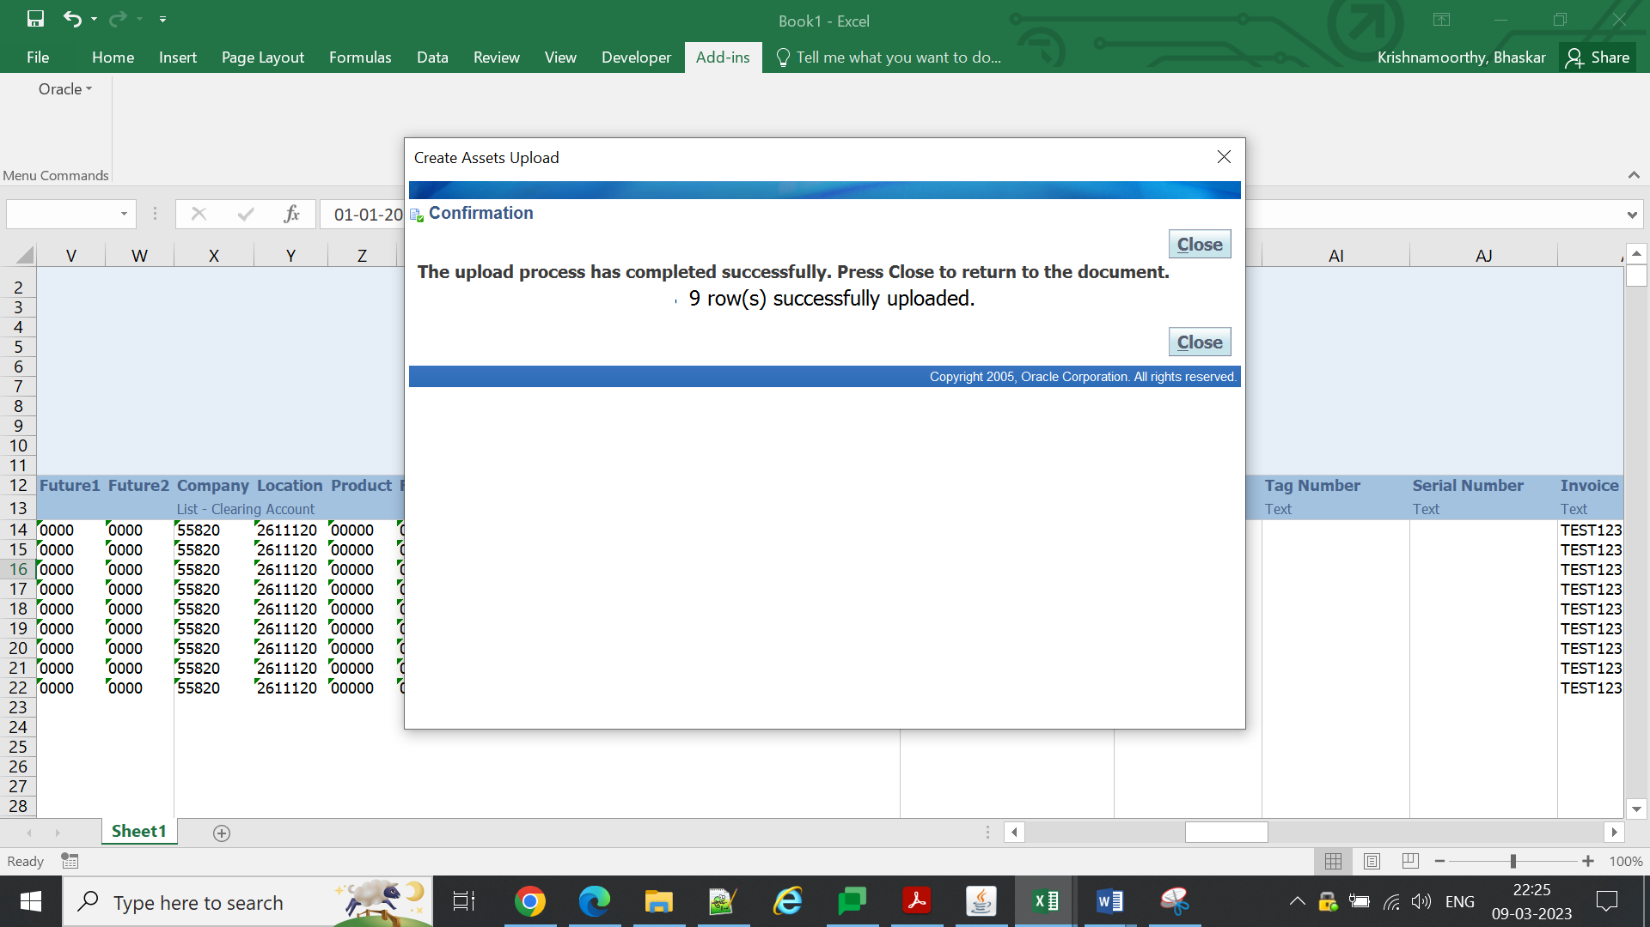

Go to mass addition and find the assets loaded
Queue-New
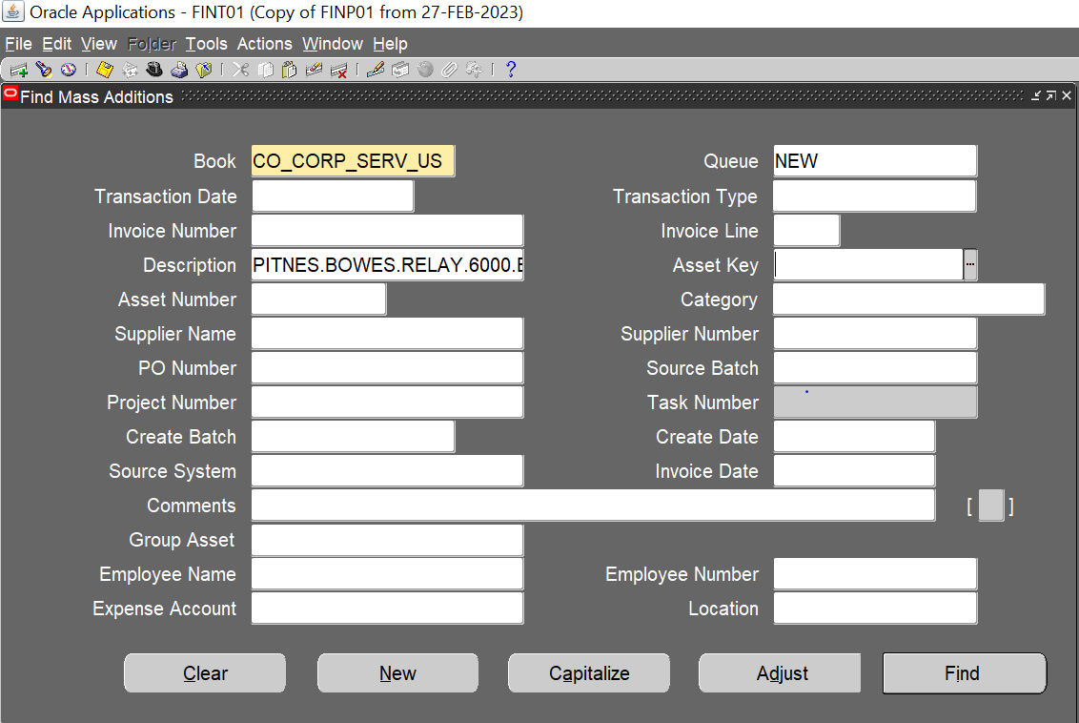
List of invoices uploaded
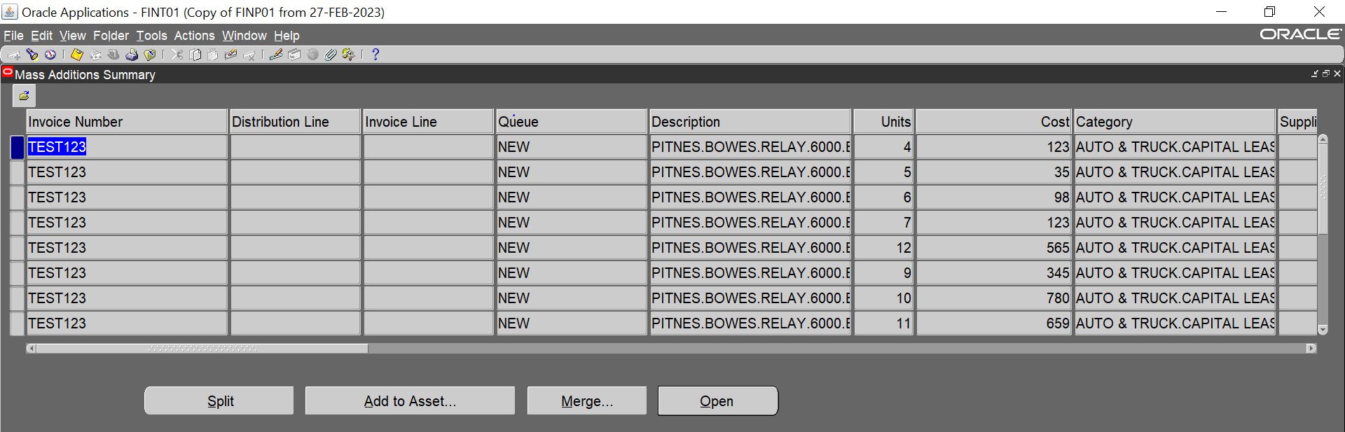
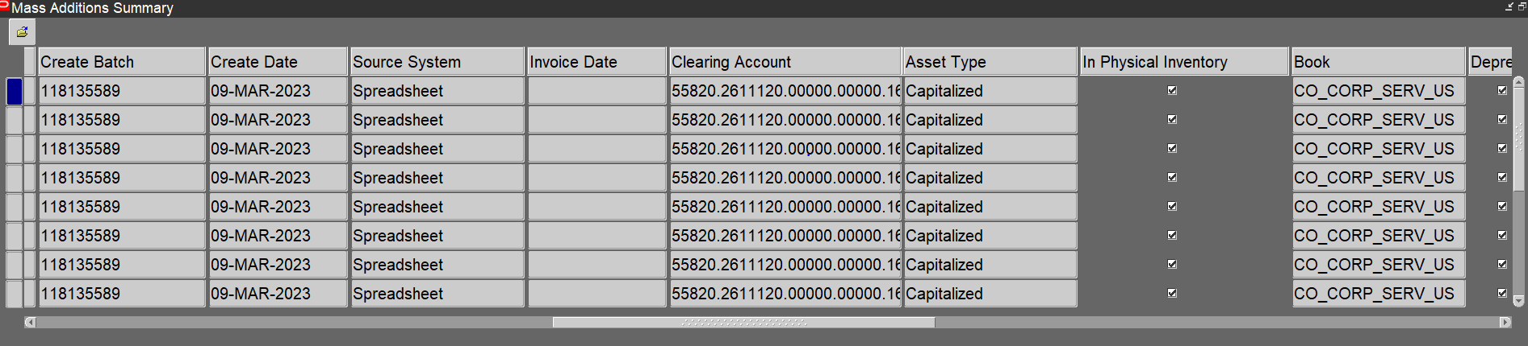
Change the que – Post

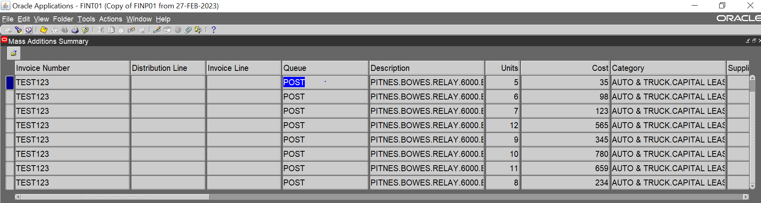

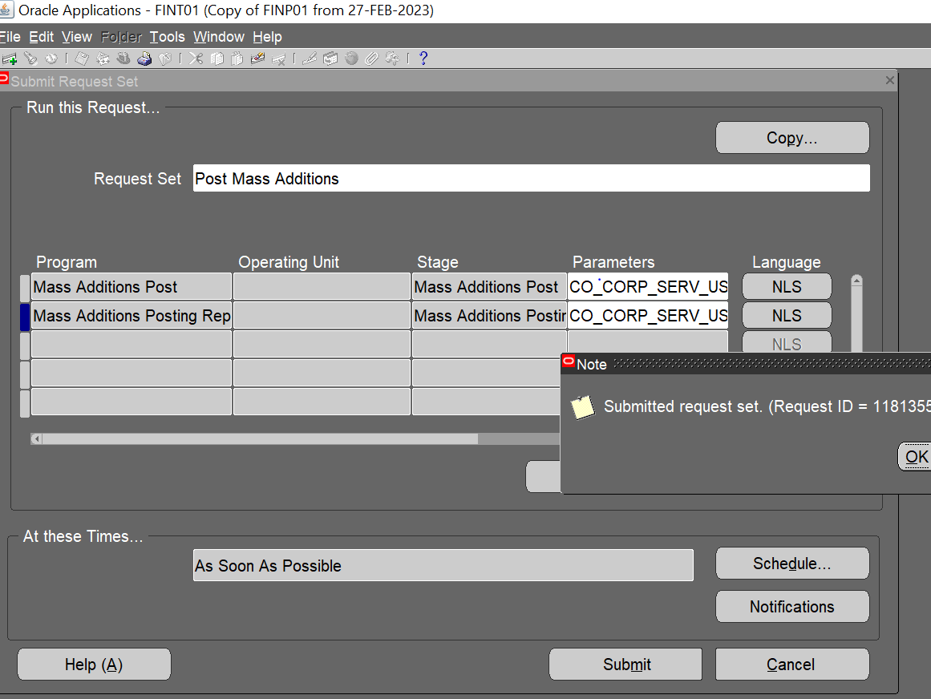

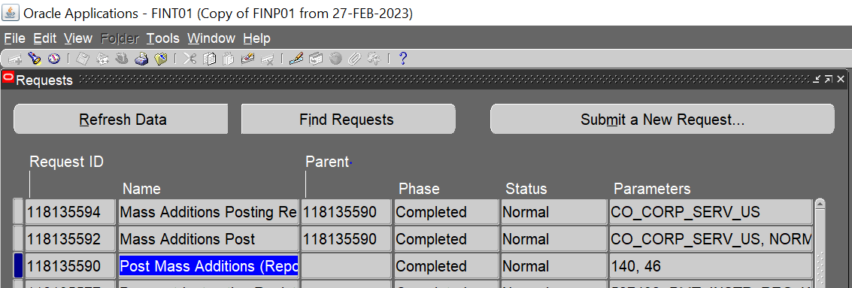

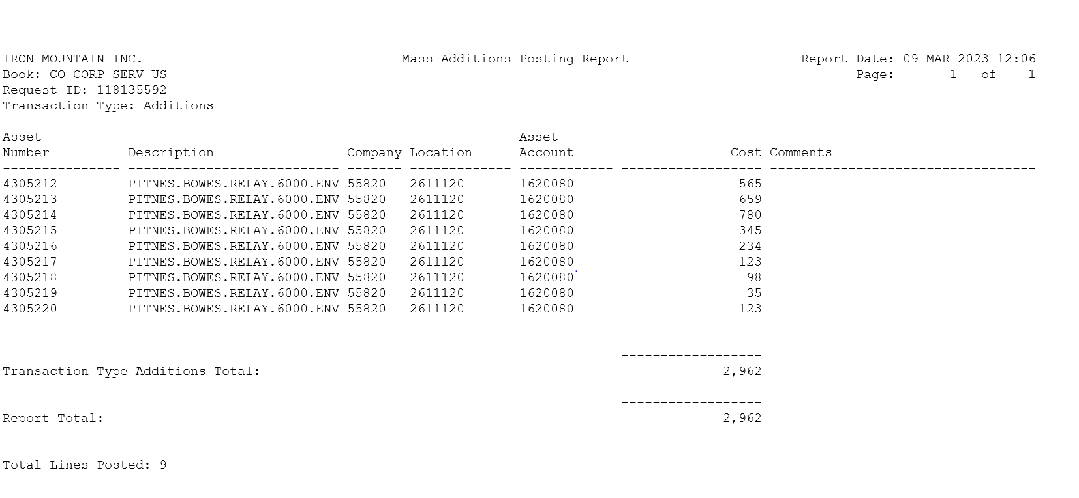
All the asset has been created
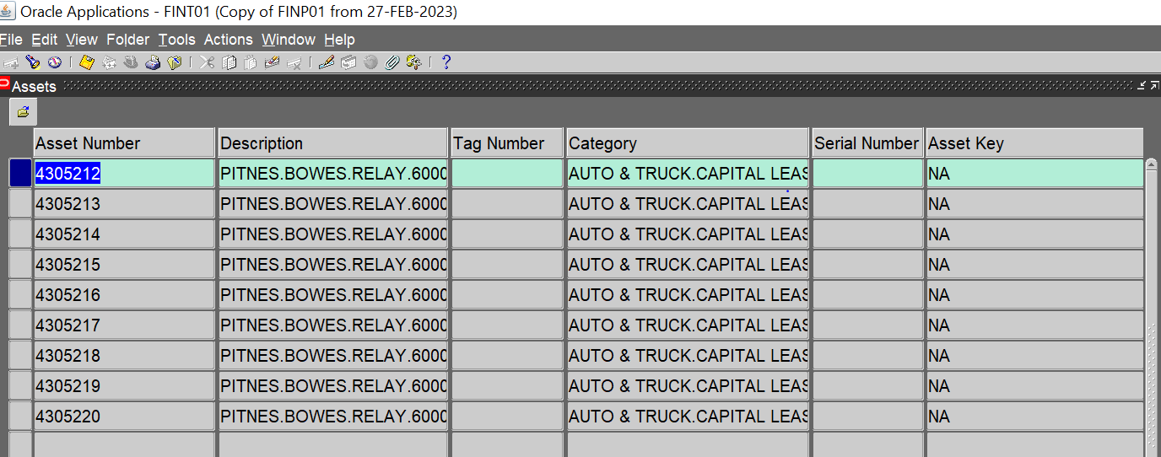

Conclusion:

Benefits of WebADI
Simply put, WEB ADI connects Excel with Oracle applications and enables data uploading.
- Minimal training required
- Useful for large transactions
- User-friendly
- Increased productivity

