TAX Exception on customer

How to create Tax Exemption:
Navigate to Tax Manager à Parties à Party Tax Profiles
Query the specific Customer (make sure the party type is ‘Third Party’)
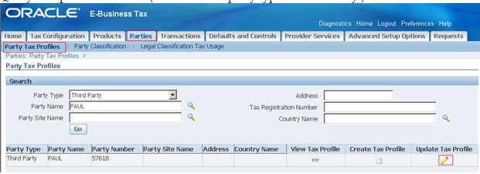
Now click on ‘Update Profile’
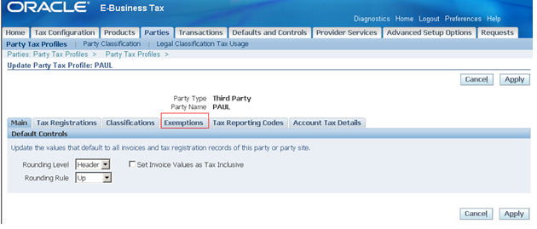
Go to Exemptions tab

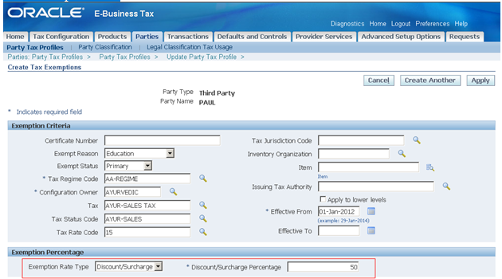
Enter all the details shown above
Here the rate entered Discount / Surcharge %: 50 and click on Apply
Actual rate is 15 %, Discount %: 50, New rate: 15 * 50/100 = 7.5 %

When there are no Tax Exemptions, the tax rate is 15 % and below is the example

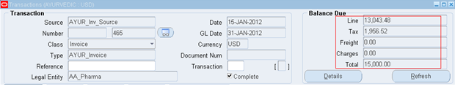
13,043.48 * 15/100 = 1,956.52

We will enter a Transaction, to see the how Tax Exemptions work

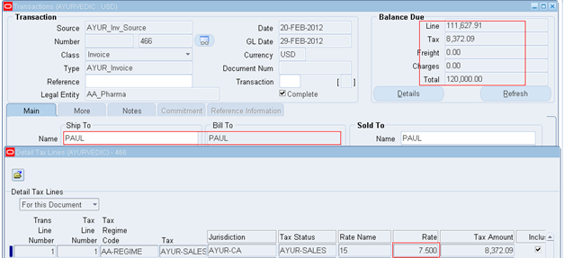
111,627.91*7.5% = 8.372.09

